Japanese-Restaurant Style Salad Dressing

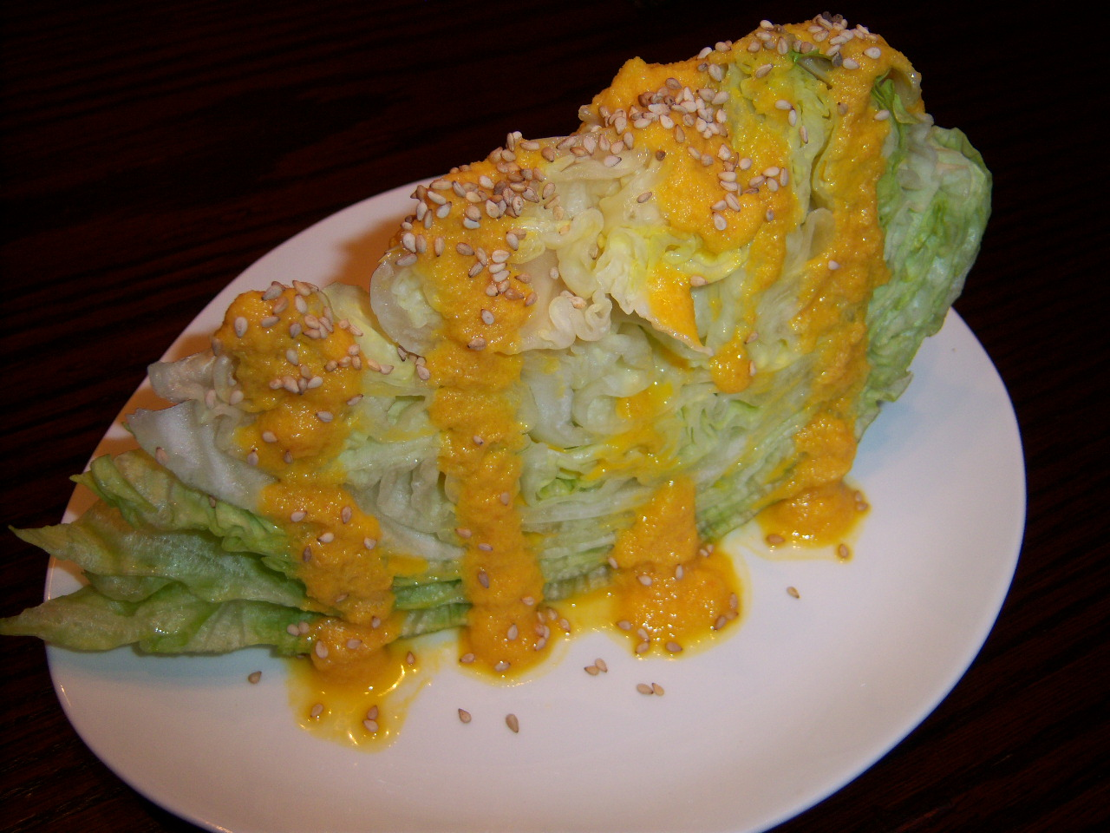

This is the recipe for that really flavorful dressing recipe served in Japanese restaurants that nobody can figure out how to make!

INGREDIENTS:

½ lb. carrots, coarsely chopped for the blender (don’t use a food processor – it doesn’t work for this)
¼ cup water
¼ cup seasoned rice vinegar, or plain rice vinegar with ½ teaspoon sugar added
3 Tablespoons ginger, coarsely chopped for the blender
1 Tablespoon soy sauce
1 Tablespoon sesame oil
1 shallot, coarsely chopped for the blender
½ cup peanut or any vegetable oil
1 Tablespoon sherry (don’t use that “cooking sherry” crap!)
1 Tablespoon sesame seeds, toasted (my personal touch)

PREPARATION:

Place everything in a blender and puree until smooth. You’ll be blending this stuff for a LONG TIME, but you’ll never get every bit of carrot disintegrated – blend it as smooth as you can get it, then just remove any stubborn chunks of carrot with a slotted spoon and discard them.

Chill and drizzle over mixed greens or iceberg-lettuce wedges, and sprinkle with the toasted sesame seeds.

