Japanese Pork & Vegetables Stir-Fry

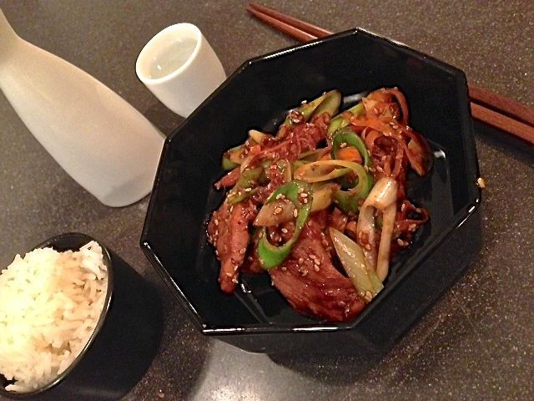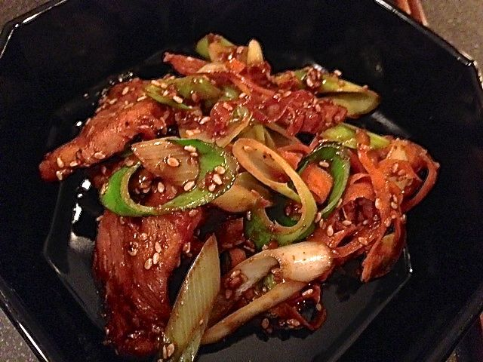

The combination of soy sauce and mirin rice wine is to Japanese cuisine as salt & pepper is to Western cuisine.

Ingredients:
½ pound boneless pork loin chops, cut into thin strips
3 tablespoons soy sauce
3 tablespoons mirin
2 tablespoons toasted sesame seeds
1 clove garlic, finely chopped
1 teaspoon finely chopped fresh ginger
2 tablespoons Asian sesame oil
1 carrot, cut into matchstick strips – I like to shave it off in peels with a potato peeler
1 small leek (“negi” in Japanese), sliced diagonally/on a bias and thoroughly washed
Salt and ground, black pepper

Preparation:
Mix mirin, soy sauce, ginger, garlic, and sesame seeds in a bowl. Marinate pork in the sauce for at least 30 minutes, up to overnight.

Heat oil in a large skillet or wok and simmer the pork and its marinade on medium-high heat until the pork is cooked through and marinade thickened. Add carrots and leek slices and stir-fry until softened. Stir-fry for about a minute.

Serve over Asian noodles, or with steamed jasmine rice in a bowl.

