Japanese Chicken Yakitori Skewers
Recipe serves 2 (makes six skewers, 3 per serving).

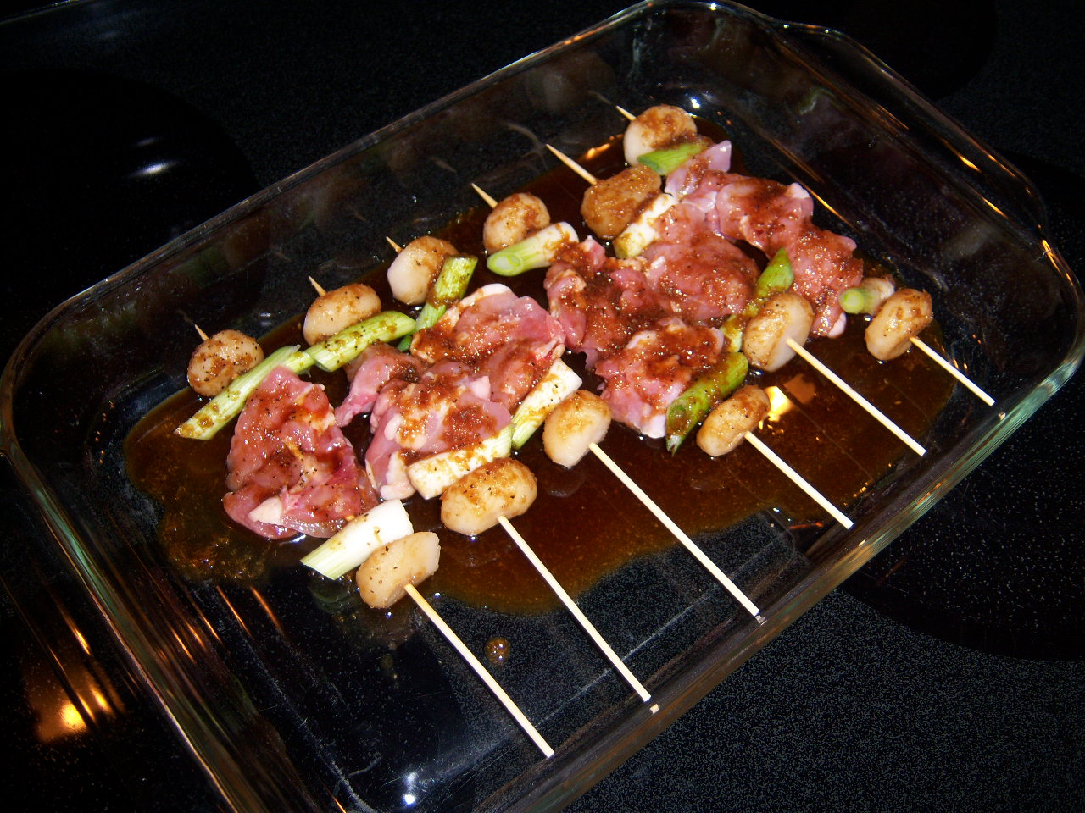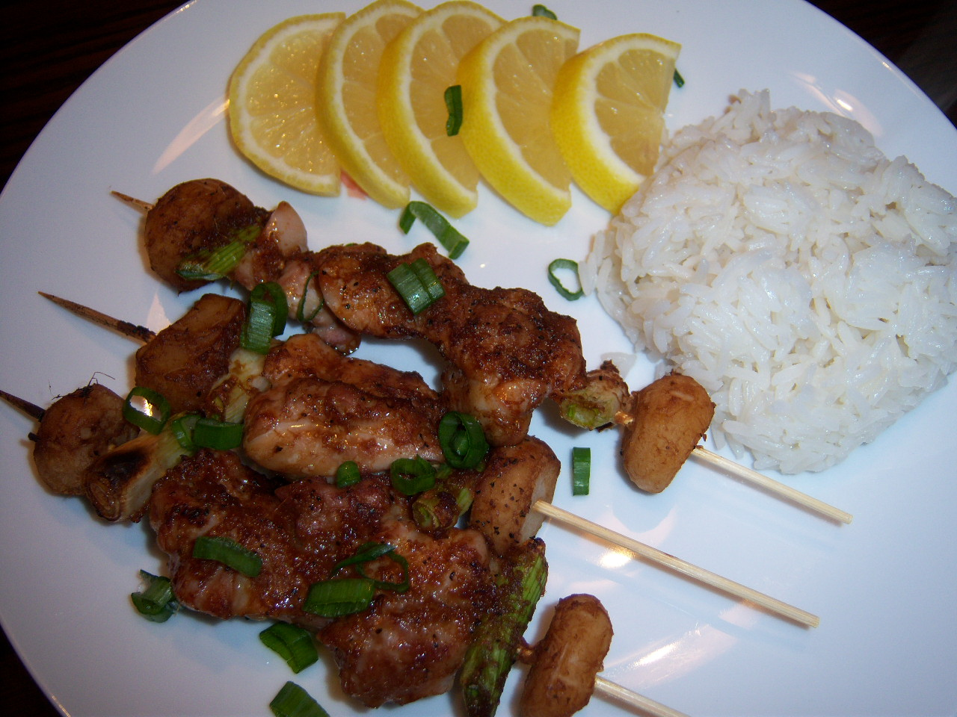

Ingredients:
¼ cup soy sauce
¼ cup sherry (don’t use that “cooking sherry” crap!)
3 teaspoons sugar
1½ teaspoons ginger, finely chopped/minced
1 clove garlic, finely chopped/minced
1 bunch scallions (six scallions), cut into 12, 1” sections; reserve and finely slice green parts
1 8-oz. can whole water chestnuts
½ lb. boneless, skinless chicken thighs, cut into 1” – 2” dice
ground, black pepper to taste
lemon wedges for garnish (optional)
small wooden/bamboo skewers, no more than 8” long

Preparation:
For the marinade, combine the ginger, garlic, soy sauce, sherry, sugar, salt and pepper in a small saucepan. Bring to a boil, then simmer on low about 5 minutes. Pull it off and allow to cool.

Thread the chicken, scallions and water-chestnut slices onto skewers, placing first a water chestnut, then a scallion section, then a piece of chicken, scallion section, water chestnut. Place the skewers in a shallow baking dish or plate and pour the marinade over them. Marinate at room temperature, turning once, for 30 minutes (the skewers can be marinated longer, up to overnight, in the fridge, turning periodically.)

Preheat oven broiler. Arrange the skewers on a greased, wire wrack on a foil-lined baking sheet, reserving the marinade. Broil the skewers, basting occasionally for the first 6 minutes. Continue to broil, turning occasionally, until the chicken is just cooked through, about 10 minutes. Discard any remaining marinade. Transfer the skewers to a platter and serve with rice garnished with lemon wedges and some of the sliced scallion greens.

