Indian-Style Halibut with Coconut Sauce (makes 4 servings)

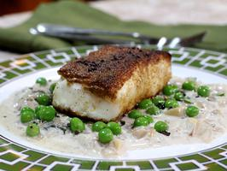

INGREDIENTS:

COCONUT SAUCE- HALIBUT- SAUTEED PEAS-
2 TBS. oil 3 TBS. oil 2 TBS. butter
1 TBS. finely chopped ginger 4, 4 to 6-oz. halibut fillets 1 tsp. mustard seeds
1 medium onion, thinly sliced 1 tsp. ground coriander 1 cup green peas
1/4 cup dried curry leaves 1 tsp. ground cumin salt and pepper
1 TBS. coriander seeds, crushed salt and pepper
1 green chili, minced
1 cup coconut milk
salt and pepper

DIRECTIONS:

For the coconut sauce: Place a large skillet over medium-high heat and add the oil. When it is hot, add the ginger and onions and cook until golden, 3 to 5 minutes. Add the curry leaves, coriander seeds and green chili and cook for 30 seconds. Add the coconut milk, turn the heat down to low and continue to cook until the sauce has thickened, 3 to 5 minutes. Taste for seasoning and add salt as needed. Keep warm.
For the halibut: Place a large nonstick skillet over medium-high heat and add the oil. Sprinkle the halibut with the coriander, cumin, salt and pepper and place them in the pan. Cook on one side for 4 minutes, and then turn the heat down and continue to cook until they are done, 3 to 4 minutes. Keep warm.
For the peas: Place a small skillet over medium-high heat and add the butter. When it begins to foam, add the mustard seeds and cook until they begin to pop, about 1 minute. Add the peas and sauté until they are bright green and tender-crisp, 3 to 5 minutes. Season with salt and pepper.
To serve: Ladle some coconut sauce on each of 4 plates. Place a halibut fillet over it and garnish with sauteed peas.

