Indian-Spiced Chocolate “City Cake”

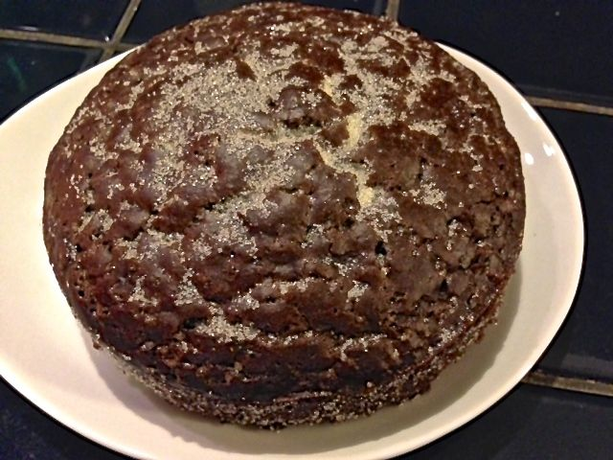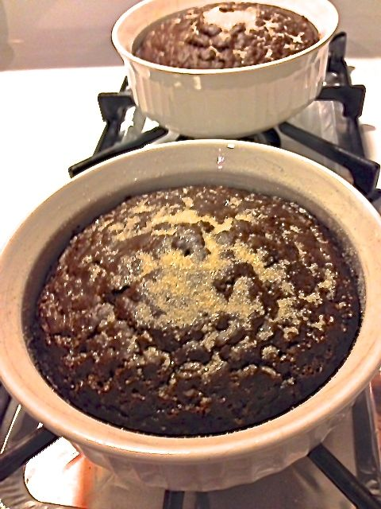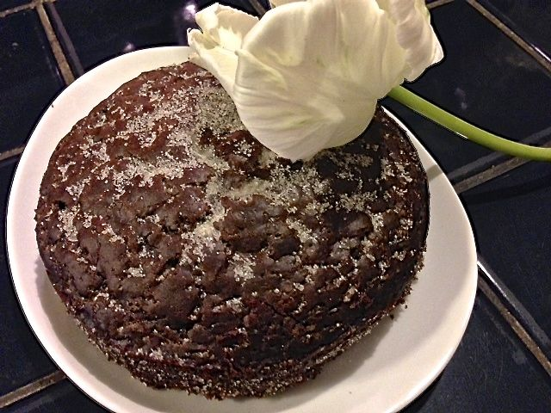

Ingredients:
1½ cups all-purpose flour
¾ cup raw sugar
2 tablespoons cocoa powder
1 teaspoon baking soda
½ teaspoon salt
½ teaspoon ground fennel (I use ½ teaspoon garam masala)
½ teaspoon ground cardamom (I use another ½ teaspoon garam masala)
1 cup warm water
¼ cup vegetable oil
1 tablespoon white vinegar

Special Equipment: Two 6” x 3” round ramekins

Preparation:
Preheat the oven to 350 degrees F. Grease the ramekins.
In a large bowl, combine the flour, sugar, cocoa powder, baking soda, salt, fennel, and cardamom and whisk to combine.
In a 2-cup measuring cup, whisk together the water, vegetable oil, and vinegar and then add to the dry ingredients. Mix well and pour the batter into the prepared ramekins.

Bake for 30 minutes. The cake is done when a toothpick comes out clean when inserted into the center of the cake.

Cool on a rack a few minutes. Run a knife around the cake to remove it from the pan to serve. Sprinkle additional sugar on top before slicing.

