Indian Bitter Melon Stuffed with Spiced Tomatoes for Two

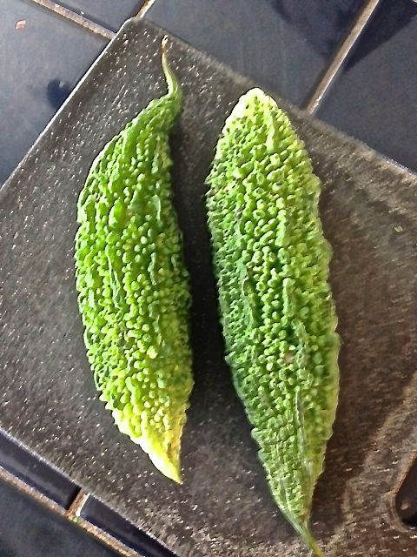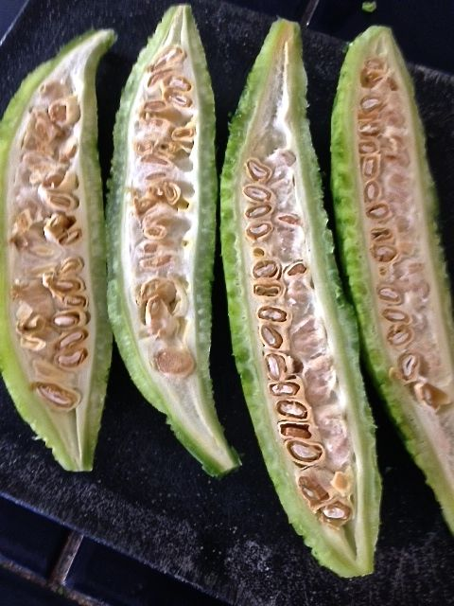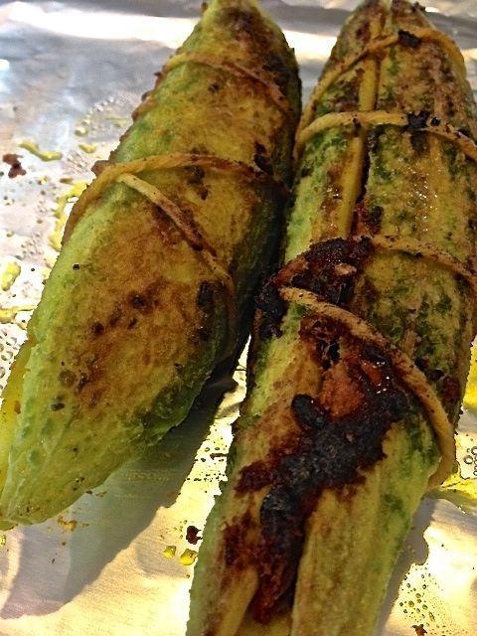

Exotic to the typical Western pallet, I’ve been told that these are the real Indian-food deal which are sure to make anyone from India homesick. There’s just no way to avoid using your hands to put the stuffing into the melons, so, unless you want your hands stained yellow by the turmeric, wear latex gloves to make these.

Ingredients:
2 bitter melons
2 tablespoons vegetable oil
1 very small onion, chopped
1 tablespoon grated fresh ginger or Indian ginger paste
1 large Roma tomato, seeded and chopped
3 to 4 fresh or dried curry leaves
1½ teaspoons garam masala
½ teaspoon mustard seeds
½ teaspoon ground turmeric
½ teaspoon salt

Preparation:
Preheat the oven to 425° F.
Peel the tough exteriors off the melons and cut them in half lengthwise, then scoop out the pulp and seeds to create a pocket on the inside of each half. Set the melon halves aside.
Put 1 tablespoon oil in a large skillet over medium-high heat, add the onion and ginger and cook for 4 minutes, or until the onion is soft and golden. Add the tomato, curry leaves, garam masala, mustard seeds, ground turmeric and season with salt. Cook the mixture for 5 minutes, stirring occasionally. Let cool slightly and then spoon into bitter melon halves. Tie halves back together with kitchen string.
Put the remaining tablespoon of oil in a clean skillet and place over medium-high heat. Brown the stuffed melons on all sides and then place them on a baking sheet.

Bake until the melons are fork tender, about 30 minutes.

