Indian Spicy Seared Shrimp for Two

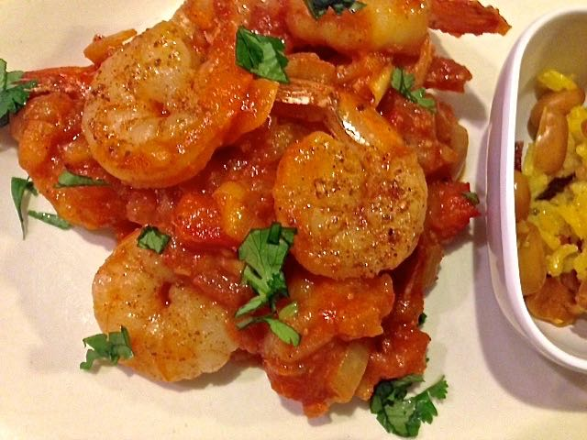

Ingredients:
1 pound fresh large raw shrimp (have fish monger shell and devein for you)
2 tablespoons vegetable oil
¼ teaspoon coriander seeds
¼ teaspoon fennel seeds
½ teaspoon cayenne powder (more if desired)
¼ cup chopped onion
1 tablespoon Indian garlic paste or minced, fresh garlic
1 tablespoon Indian ginger paste or grated, fresh ginger
¼ teaspoon ground turmeric
8 ounces tomato sauce
½ teaspoon ground cumin
¼ teaspoon salt
2 tablespoons cilantro, minced
Fresh, chopped tomato, to taste

Preparation:
Peel and devein the shrimp. Rinse, pat dry with paper towels.

Grind the coriander seeds and fennel seeds into a fine powder in a spice grinder. Mix it with the cayenne and coat the shrimp lightly and evenly over both sides. Let the coated shrimp sit until ready to cook.

When ready to cook, heat the oil in a skillet over medium-high heat. Add coated shrimp and sear for 1 – 2 minutes, or until color just turns pink and there’s a nice sear on all sides of shrimp. Remove to the side.

Reduce heat to medium; add onion, garlic, ginger, and turmeric to the pan. Cook 2 to 3 minutes, while stirring, until onion is translucent. Stir in tomato sauce, fresh tomato, more cayenne (to taste), ground cumin and salt. Add shrimp back in and sauté about 2 – 5 minutes, until done. Do not overcook as shrimp toughen quickly.

Garnish with cilantro and serve warm with steamed basmati rice and Indian flat bread.

