Potatoes in Onion and Tomato Sauce for Two (recipe makes 2 cups)

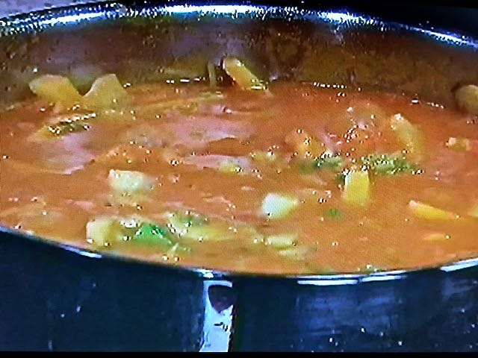

This hearty, tomato-based sauce served with potatoes makes an excellent side dish.

Ingredients:
2 tablespoons oil
1 bay leaf
2 to 3 slivers cinnamon sticks
½ teaspoon cumin seeds
1 teaspoon black mustard seeds
½ medium onion, cut lengthwise (about 1/2 cup)
½ cup chopped tomato
½ pound potatoes, peeled and cut in oblong pieces (1 1/2 cups)
¼ teaspoon ground turmeric
½ cup tomato sauce
1 teaspoon ground cumin
½ teaspoon cayenne pepper
¼ teaspoon salt
1 1/2 cups hot water
1/4 cup chopped fresh cilantro

Preparation:
Heat oil in a skillet over medium heat (the oil should be hot but not smoking). Add bay leaf, cinnmanon, cumin seeds, and mustard seeds and stir until mustard seeds start to pop and cumin seeds change color from light brown to semi-dark brown.

Add onion, tomato, potatoes, and turmeric to saucepan. Stir and cook over medium-low heat for 1 to 2 minutes.

Stir in tomato sauce, ground cumin, cinnamon, cayenne pepper, and salt. Bring to a simmer. Add 1.5 cups hot water and cilantro; stir to combine. Cover and cook over medium-low heat about 8 to 10 minutes, stirring occasionally, until potatoes are tender.

