Indian Potato Masala – recipe makes two servings

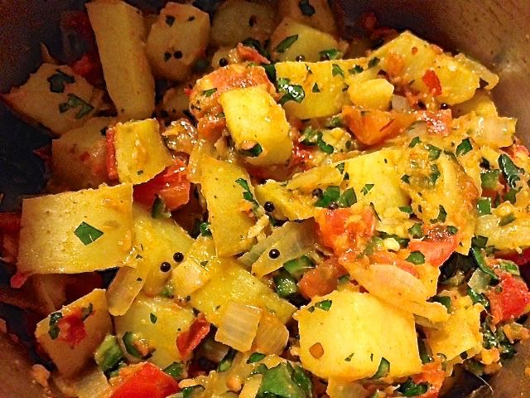

Ingredients:
2 medium-large waxy potatoes (like Yukon golds), cleaned, but unpeeled
½ teaspoon ground turmeric
½ teaspoon salt
2 tablespoons vegetable oil
¼ teaspoon asafoetida
4 – 6 curry leaves, or to taste
1 teaspoon black mustard seeds
1 teaspoon urad dal
1 medium onion, chopped (about a cup)
1 small tomato (about ½ cup), chopped
1 green chili, minced
1 tablespoon fresh ginger, minced, or Indian ginger paste
¼ teaspoon cayenne powder
¼ cup fresh cilantro, finely chopped/minced

Preparation:
Cut the potatoes into bite-sized dice. Boil the potatoes for 10 minutes with a little turmeric and the salt in the water. Set aside.

Pour a couple tablespoons oil into a hot skillet and fry the curry leaves a minute or two. Add in the asafoetida, the mustard seeds, and urad. Cook until the mustard seeds pop and urad is golden.

Add in the onion. Stir and cook until soft. Stir in the tomatoes, and season everything with a little more salt. Fry until soft.

Add the turmeric, ginger, and potatoes. Gently stir. Add in the cayenne and chili. Cook a bit more, then stir in the cilantro – do not break up the potatoes too much, if you can help it. Serve as a side dish or as a main coarse.

