Indian Lemon Rice (makes 2 – 3 servings).

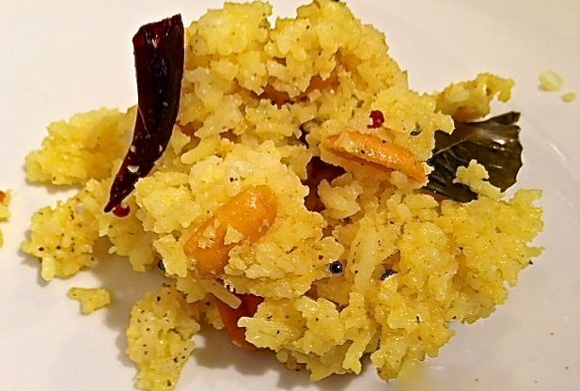

Ingredients:
1 cup cooked basmati rice (leftovers work perfectly), that’s ½ cup raw rice cooked
1½ teaspoons peanuts
½ teaspoon turmeric powder
2 – 4 tablespoons lemon juice, more to taste
Salt and ground, black pepper, to taste

For Tempering
1 tablespoon sesame seed oil (Indian version)
1 or 2 dried, red chilies torn into halves
¼ teaspoon mustard seeds
1½ teaspoons urad dal
A generous pinch of asafoetida
A few curry leaves, dried will do just fine
Chopped coriander (cilantro) leaves for garnishing (optional)

In Indian cooking, “tempering” is a method of preparing spices by frying them quickly together in hot oil.
Preparation:
Heat oil for tempering in a pan and add the peanuts. Roast until nicely browned. Drain and set aside.

To the hot oil, add the ingredients for tempering. Take care not to burn the chilies. When the mustard seeds start to pop and the dal has turned a golden brown, add the turmeric powder and salt. Add the peanuts, cook until brown, mix well and remove from fire.

Add cooked rice to the above mixture and mix well. Squeeze lemon juice on the rice and mix again. Depending on the lemon you use, the sourness will vary. Make sure you make it slightly more sour than you need it because when you let it sit for an hour or two, the rice will absorb the flavors.

Garnish with chopped cilantro and serve.

