Indian Garlic-Pepper Chicken (recipe makes two servings).

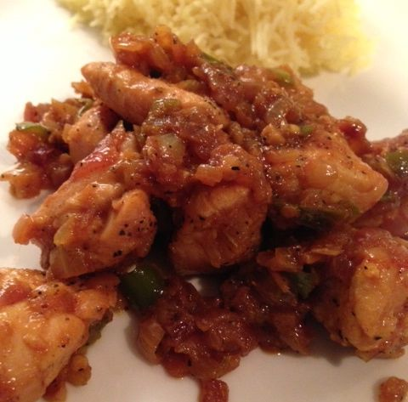

INGREDIENTS:
½ lb. boneless, skinless chicken, cut into bite-sized pieces
1 medium yellow or white onion, finely chopped
1 medium red onion, finely chopped
4 - 5 cloves garlic, sliced
1 tablespoon minced ginger
3 Serrano chili peppers, minced
oil, for frying
1 cinnamon stick, or ¼ teaspoon ground cinnamon powder
1 bay leaf
2 dried, red chili peppers, minced with scissors
½ teaspoon cumin powder
¼ teaspoon fennel seeds, crushed
½ teaspoon turmeric powder
1 teaspoon freshly-ground black pepper
¼ teaspoon salt
1/8 teaspoon granulated garlic powder
1 teaspoon commercial curry (sahmbar) powder
½ teaspoon cayenne powder

PREPARATION:
Season the chicken with a little salt, black pepper and granulated garlic powder. Heat oil in a large saucepan over medium-high heat and brown the chicken in it well. Remove chicken to a plate to the side.

Heat a little more oil in the saucepan and add in the bay leaf, red chilies, cinnamon, cumin, turmeric powder, fennel, the black pepper, salt and remaining spices; fry a second or two to bring out the aroma and develop the flavors.

Add the onion and garlic; fry until translucent. Add the chicken back into the pan. Stir in the ginger and cook until everything is warmed through. Remove bay leaf and cinnamon stick before serving with basmati rice and naan or roti bread!

