Indian Chickpea & Mango Rice

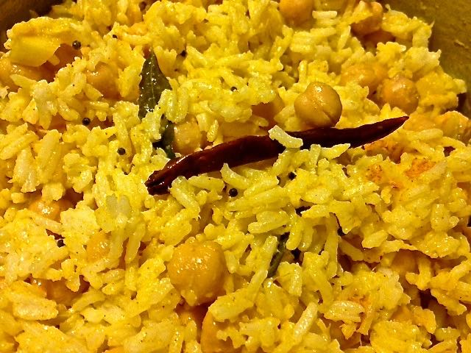

Ingredients:
1 tablespoon vegetable oil
1 whole, dried red chili
½ teaspoon black mustard seeds
½ teaspoon ground turmeric
¼ teaspoon salt
1 tablespoon grated fresh ginger
1 teaspoon minced, fresh green chili
1 tablespoon lemon juice
2 cups cooked basmati or other long-grain, white rice (I like to boil the rice with a few fresh curry leaves)
1, 15-ounce can chickpeas, drained and rinsed
½ a barely ripe (not too ripe), firm mango, finely chopped

Preparation:
Bring a small saucepan to medium-high heat, then add in the oil. When the oil is hot, add the red chili to start the tempering. Let the chili get a little toasted, then add in the mustard seeds and sauté until they start popping. Then add in the ginger, turmeric, chickpeas and the rice. Turn heat down to low and add in the green chili, salt and remaining ingredients.

Heat through and serve. Rice freezes well.

