Indian Carrot Halva (creamy festival dessert pudding)
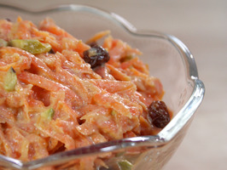 Recipe serves 4.

INGREDIENTS

1 pound carrots, peeled and grated
1/2 cup ricotta cheese (may use fat-free)
1/4 cup raisins
2 tablespoons chopped pistachios
1 teaspoon ground cardamom
1/8 teaspoon ground cloves
2 cups milk (may use 2%, but whole milk makes it so creamy!)
2 tablespoons cane sugar or honey

DIRECTIONS

Put the carrots, cheese, raisins, pistachios, cardamom, cloves, milk, and honey into a large saucepan and bring to a boil over medium heat. Reduce the heat to low and simmer, stirring often, until the carrots are soft and the mixture has thickened, about 15 to 18 minutes. May serve warm or cold!

