Indian Beef & Peas (recipe makes 4 servings)

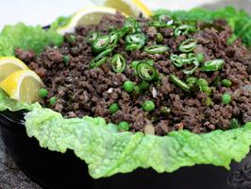 This dish is tradionally vegetarian, but Chef Bal Arneson (“Spice Goddess”) spiced it up with, of all things, BEEF (YUM)!

INGREDIENTS
2 tablespoons oil
1 tablespoon minced ginger
1 medium onion, finely chopped
1/4 cup dried curry leaves
1 tablespoon garam masala
1 teaspoon black mustard seeds
1/2 teaspoon cardamom seeds
1 pound ground beef
1/8 teaspoon salt
1 cup frozen peas
6 - 8 savoy cabbage leaves
Sliced green chilies, for garnish
Lemon wedges, for garnish and to squeeze juice over beef

DIRECTIONS

In a skillet set over medium-high heat, add the oil. When it's hot, add the ginger and onions and cook until softened and beginning to turn golden, about 3 minutes. Add the curry leaves, garam masala, mustard seeds and cardamom seeds, and cook for 20 seconds.

Add the ground beef, sprinkle with salt and stir to break up any chunks. Continue to cook until the beef is cooked through, about 8 minutes. Stir in the peas and cook until they turn bright green, about 2 minutes.
Place a stovetop steamer over medium-high heat and bring to a boil. Add the cabbage leaves and steam until bright green and tender, 2 - 3 minutes. Place them on a platter; garnish with green chilies and lemon wedges.

Spoon beef into a leaf, squeeze some lemon on and make into a wrap to eat (like Korean beef is eaten)!

