Ice-Cold Korean Summertime Noodles with Beef for Two (Naeng Myung)

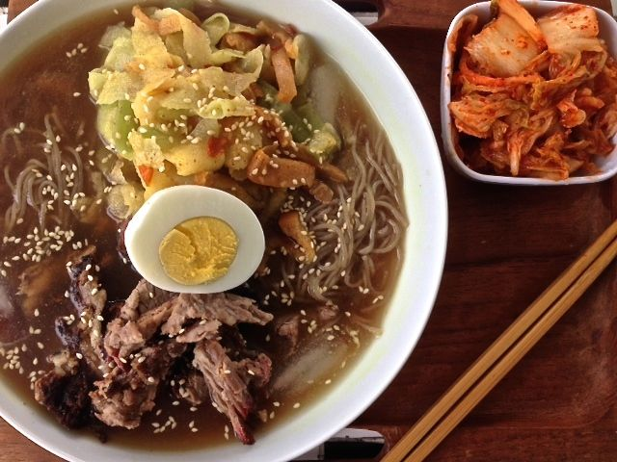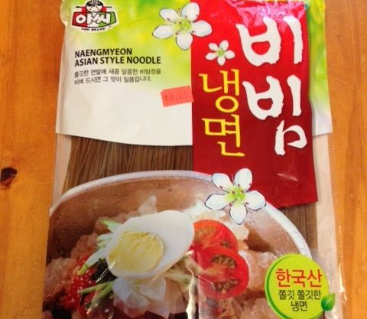

Naeng myun (or naengmyoen) is a Korean cold noodle dish made of thin, slightly chewy buckwheat noodles in a savory, vinegary ice-cold broth. Although now a summertime food in Korea, it originated in the North Korean mountains as a wintertime staple. But this is so refreshing in hot weather. All the Asian ingredients are sold at Pacific Produce in Milwaukee on South 27th Street.

Ingredients:
4 ounces Korean naengyun noodles (don‘t use soba or memil gooksu noodles)
1 cup chicken broth
1 cup beef broth, unsalted
2 tablespoons rice vinegar
2 tablespoons white vinegar
1 small Asian pear, julienned or shaved with vegetable peeler into paper-thin slices
1 egg, hard-boiled and sliced in half
½ Korean cucumber, seeded and shaved with vegetable peeler into paper-thin slices
¼ cup pickled radish
4 ounces cooked beef brisket, thinly sliced (I use Whole Foods’ smoked brisket)
2 teaspoons Korean or English prepared mustard
1 teaspoon sugar
A sprinkling of sesame seeds to garnish

Preparation:
Mix cooled chicken and beef broths together with vinegar. Add more salt or vinegar to taste (enough so that it’s quite tangy). Chill in refrigerator for at least an half hour.

Cook noodles according to package directions, about 3 - 5 minutes in boiling water.
Drain noodles and rinse well in cold water to stop cooking and eliminate some excess starch. Use your hands to massage out excess water. Cut with kitchen sheers into 2” – 3” lengths.

Toss the vegetable slices and pickle to taste with more vinegar, sugar, and mustard. Distribute noodles into bowls, mounding at bottom. Pour a generous amount of chilled broth and a few ice cubes to cover almost of all of noodles. Place half a boiled egg, half the vinegar-mustard vegetable salad and brisket slices on top of the noodles. Lightly sprinkle sesame seeds over each bowl. Serve immediately.

