Gulab Jabun (Sweet Indian Donut Fritters) for Two - 6 fritters per serving

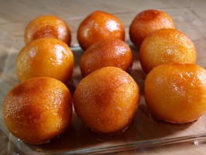

Ingredients:

For the Syrup
5 cups white, granulated sugar – the kind you put in your tea or coffee
4 cups water
8 green cardamom pods
8 cloves
2 star anise

For the Doughnuts
3 cups dry/powdered milk powder
1 cup all-purpose flour
½ teaspoon baking soda
1¾ cups whipping cream
½ cup oil, for frying

Preparation:
For the syrup, put the sugar, water, cardamom pods, cloves, and star anise in a medium-size saucepan and bring to a boil. Turn the heat to low and simmer until the sugar has dissolved and the syrup is slightly thickened, about 25 minutes. Let the syrup cool slightly.
For the doughnuts, mix the dry milk powder, all-purpose flour, and baking soda together in a large bowl and then slowly stir in the whipping cream until a loose dough is formed.
Oil your hands (I wear latex gloves), and then divide and form the dough into balls about the size of golf balls. Heat the oil over very low heat in a high-sided sauté pan and carefully begin to add the balls. Fry the doughnuts slowly until they are golden on all sides, about 2 to 3 minutes per doughnut. Be careful not to burn them. Put the doughnuts into the syrup and let them sit for at least 15 minutes. Remove the doughnuts from the syrup and serve warm or cold.

