General Tso's Chicken
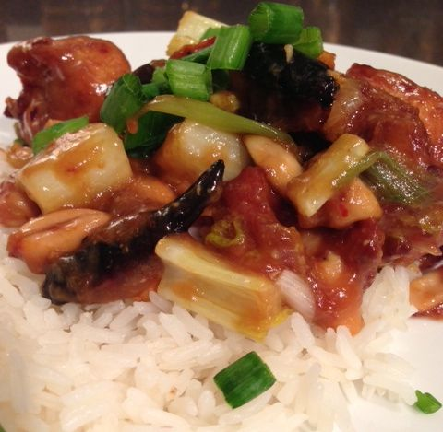 Recipe makes 2 servings.

Ingredients:
1 large egg white – save the yoke for breakfast!
3 tablespoons cornstarch
3 tablespoons Chinese cooking wine or dry sherry
3 tablespoons soy sauce
½ - 1 pound boneless, skinless chicken, cut into 1-inch cubes
¼ cup chicken stock
2 teaspoons white-wine vinegar
2 teaspoons sugar
vegetable oil, for frying
12 dry red chili peppers
1 tablespoon minced garlic
1 tablespoon minced ginger
½ teaspoon red pepper flakes
½ cup sliced green onions (I also like to add about ½ cup of any other chopped vegetable I have on hand, like celery or bell pepper)
½ cup lightly toasted cashews or peanuts
green onions, sliced on the bias, for garnish
hot, steamed white rice, accompaniment

Directions:
Put the chicken pieces in a 1-quart, zip-lock bag. In a small bowl, whisk the egg white well until it is thick and frothy, but does not create peeks. Mix in 2 tablespoons of the cornstarch, 2 tablespoons of the wine, and 1 tablespoon of soy sauce. Add it to the bag of chicken and toss to coat. Let marinate in the refrigerator for 30 minutes to an hour.

To make the sauce: Rinse out the bowl, then whisk in it the remaining 1 tablespoon cornstarch with 1 tablespoon of the chicken stock until smooth. Add the remaining chicken stock, 1 tablespoon wine, 1 tablespoon soy sauce, the vinegar, and sugar; whisk to combine. Set aside until ready to finish the dish.

In a large wok or pot, heat enough oil to come 3 inches up the sides to 350 degrees F.

Remove the chicken from the marinade and carefully slide into the hot oil. Fry, turning, until golden brown and cooked through, about 2 minutes. Remove and drain on paper towels.

Discard all but about 1 tablespoon of the oil from the wok. (Alternatively, in a clean wok or sauté pan, heat 1 tablespoon of oil over medium-high heat.) Add the chili peppers and stir-fry until nearly black. Add the garlic, ginger, red pepper flakes, nuts and green onions with any other vegetables you like. Stir-fry until fragrant, about 15 seconds. Add the chicken stock sauce, bring to a boil, and cook, stirring, until the sauce thickens, about 1 minute. Remove from the heat.

Arrange the chicken on a platter and pour the sauce over it. Garnish with the additional green onions. Serve with hot rice.

