Garlic-Ginger Soup (recipe makes 4 servings)

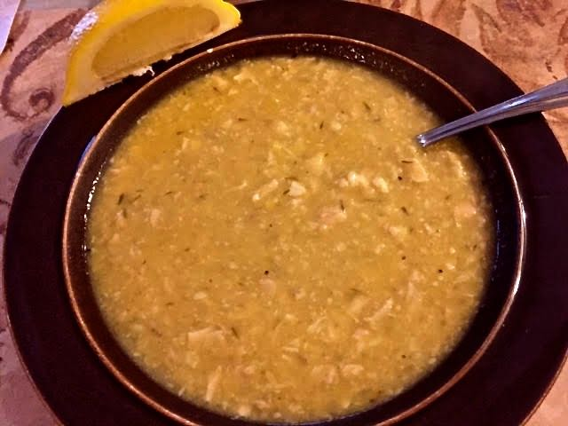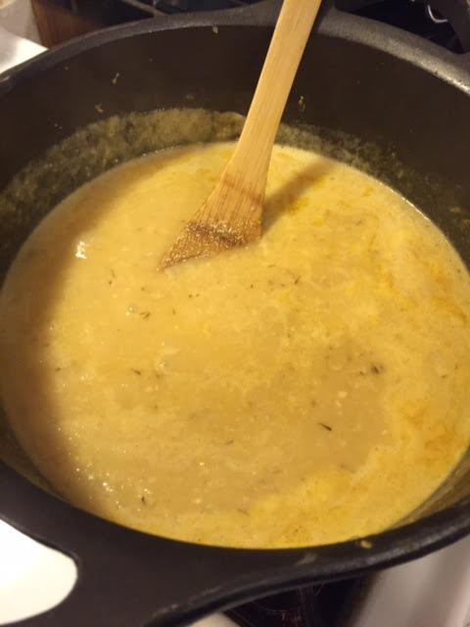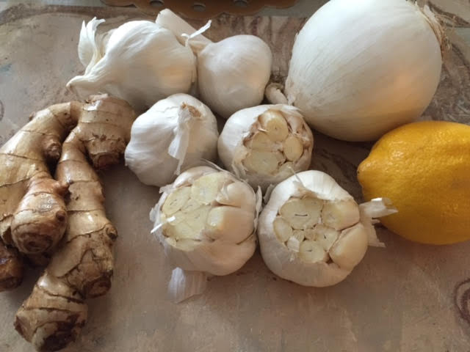

Okay, it sounds like a lot of garlic, but this recipe really works. Though it can be made vegetarian, I use chicken broth and I like to add in the finely chopped meat of half a rotisserie chicken. Save time and buy the already-peeled garlic cloves in jars.

Ingredients:
6 heads garlic, 3 of them unpeeled and the cloves of the other 3 peeled
5” – 6” piece of fresh ginger, peeled and grated (about ¾ cup’s worth)
2 medium-large, white onions, cut in half and sliced (about 2 cups worth)
2 tablespoons peanut or other vegetable oil
2 tablespoons butter
½ teaspoon cayenne powder, or to taste
1½ teaspoons chopped fresh thyme (I just use dried)
½ cup coconut milk
3½ cups vegetable or chicken broth
1 lemon, cut into 4 wedges (for serving)

Preparation:
Preheat oven to 350° F.

Cut the bottoms off of 3 unpeeled garlic heads and put them in a glass baking dish. Drizzle them with the oil and season with a sprinkling of salt. Cover the dish and bake until the garlic is golden, about 45 minutes to an hour. Squeeze out the caramelized garlic cloves with your fingers (I wear latex gloves) and set them aside.

In a Dutch oven, melt the butter over medium-high heat. Add in the onions, thyme, ginger and cayenne; cook until the onions are opaque. Season with salt and pepper, to taste. Add the roasted garlic and the peeled cloves of the remaining garlic; cook 3 – 4 minutes. Add the broth, cover and simmer 20 minutes. Working in batches, puree the soup in a blender or food processor. Return the soup to the Dutch oven and add the coconut milk; bring to a simmer until warmed up. I add in the chicken at this point and just heat it through. That squeeze of a lemon wedge into each bowl before serving makes all the difference in the world!

