Garlic and Pepper Chicken for Two

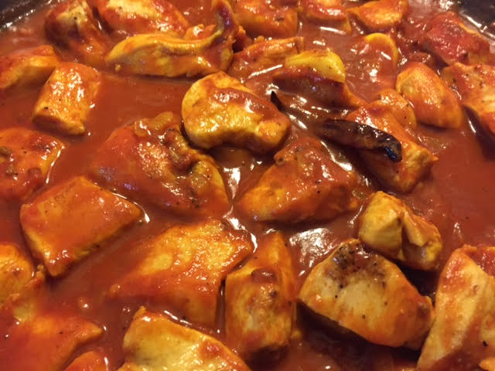 + 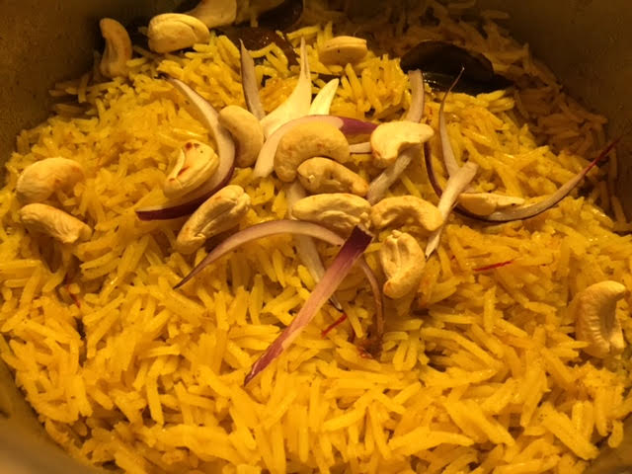 = 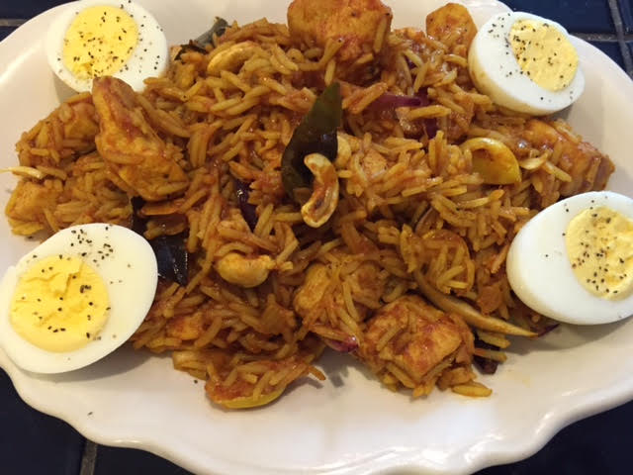 !

Standing alone, this dish makes an excellent main course for any Indian meal. However, mixing it into biriyani rice creates India’s all-time favorite dish, Chicken Biriyani.

Ingredients:
1 pound boneless, skinless chicken, cut into medium-size pieces
2 tablespoons oil
½“ cinnamon stick
1 small bay leaf
1 dried red chili pepper
½ teaspoon cumin seeds
½ teaspoon urad dal
¼ teaspoon fennel seeds
¼ cup chopped onion
5 – 6 garlic cloves, peeled and sliced in half (larger ones sliced into quarters)
¼ teaspoon turmeric powder
1½ teaspoons minced fresh ginger
¼ teaspoon ground black pepper
¼ teaspoon cumin powder
¾ teaspoon salt
½ teaspoon curry powder (more, if desired)
¼ teaspoon cayenne powder
8 ounces tomato sauce
2 tablespoons (approximately) red onion, sliced thinly lengthwise (optional)

Preparation:
Heat oil in a large skillet over medium heat. When oil is hot, but not smoking, add cinnamon stick, bay leaf, red chili pepper, cumin, urad dal fennel and seeds.
Add onion and garlic. Sauté for few minutes. Stir in turmeric powder. Add chicken and ginger to skillet. Sauté over medium heat until the chicken is browned.

Add black pepper, cumin powder, salt, curry powder, and cayenne powder. Stir well to coat the chicken with spices. Add tomato sauce and about 1 tablespoon water. Stir and cook chicken, covered, over medium heat for 12 to 15 minutes. During the cooking process, stir often to prevent chicken from sticking to the skillet.

Remove the cinnamon and bay leaf. Stir the red onions into the chicken, or mix into biriyani rice recipe to serve as Chicken Biriyani (which will make 4 servings).

