Chinese-Restaurant Fried Rice for Two

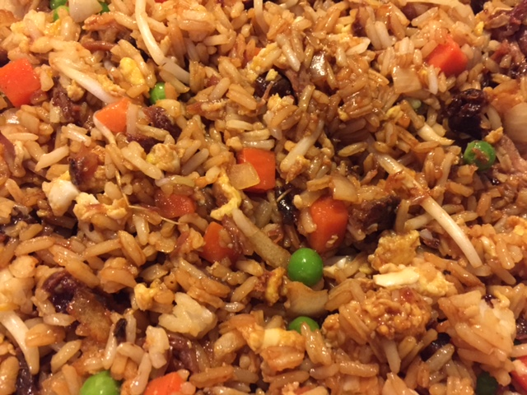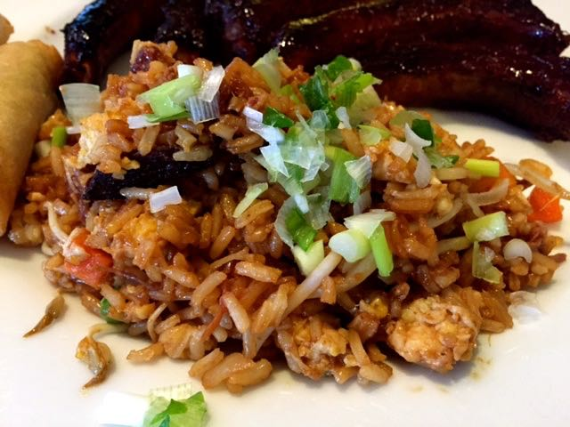

The Chinese make a whole meal out of this recipe, rather than serving it as a side dish.

Ingredients:
1 cup raw jasmine or other white long-grain rice boiled/cooked (you need about 2 cups cooked rice), chilled overnight in the fridge, then brought to room temperature
2 ounces Chinese barbecued pork (see my recipe for Chinese pork ribs, or use bacon)
1 very small onion (about 2 ounces), diced
½ cup frozen peas and diced carrots, thawed
¼ cup soy sauce
2 large eggs
¾ cup (about 2 ounces) bean sprouts
2 tablespoons vegetable oil, divided (I like using aromatic Asian sesame oil for this)
1 clove garlic, minced
1 scallion, finely chopped (optional - for garnish)

Preparation:
Heat a wok or medium-sized skillet on medium-high until it is hot, then place 1 tablespoon of the oil in it and scramble the eggs, making sure they’re broken up well. Put them into a bowl off to the side.

Add the rest of the oil and wait until it is almost smoking to fry the onion and garlic until almost transparent. Add the rice; stir-fry it for 1 minute, then add the barbecued pork or crumbled, fried bacon. Heat thoroughly by continuing to stir-fry the mixture for 5 minutes over high heat.

Next add the eggs back with the bean sprouts and continue to stir-fry for 2 minutes. Add the peas and carrots; pour in the soy sauce as well. With a quick, but gentle hand, toss ingredients over med-high heat and stir quickly. "Fry" the rice until all the soy sauce is distributed and the color and strength is to your liking.

Turn the mixture onto two plates and garnish with the scallion. Serve at once, or let it cool and serve as a cold rice salad. This recipe freezes well.

