Filipino Chicken Adobo for Two

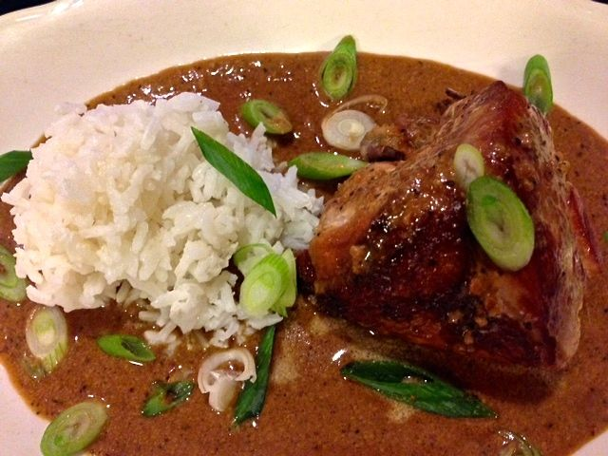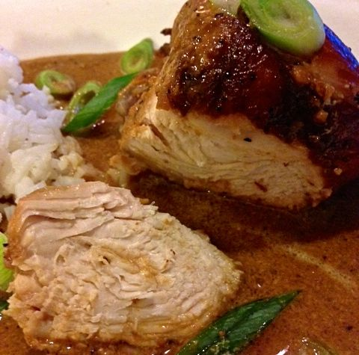

Adobo, which just means “seasoning” or “marinade,” is the national dish of the Philippines, and chicken adobo is among the most popular. Adobo varies widely from region to region, but the two core components for it all over the Philippines is vinegar and soy sauce. This recipe is a variation from the south of the big island of Luzon to the north with coconut milk added to tame the tartness and saltiness.

Ingredients:
1 bone-in, skin-on chicken breast or 2 thighs, trimmed of excess fat
3 tablespoons soy sauce
½ of a 13½ -ounce can coconut milk
¼ cup cider vinegar
4 garlic cloves, peeled and finely minced
2 bay leaves
1 teaspoon ground, black pepper
1 scallion, sliced thinly

Preparation:
Toss chicken with soy sauce in a large bowl (I put it in a quart-sized Ziploc). Refrigerate for at least 30 minutes and up to 1 hour.

Remove chicken from soy sauce, allowing excess to drip back into bowl. Transfer chicken, skin side down, to a large, nonstick skillet (don’t preheat!); save soy sauce.

Place skillet over medium-high heat and cook until chicken skin is browned, 7 to 10 minutes. While chicken is browning, whisk coconut milk, vinegar, garlic, bay leaves, and pepper into soy sauce.

Transfer chicken to plate and discard fat in skillet. Return chicken to skillet skin side down, add coconut milk mixture, and bring to boil. Reduce heat to fairly low (2 – 3 on gas range) and simmer, covered, for 20 minutes. Flip chicken skin side up and continue to cook, partially covered, until white meat reaches 160° F. on a meat thermometer in the thickest part and dark meat reaches 175° F., and until sauce is thickened, about 15 minutes. Plate the chicken and evenly pour sauce over it, sprinkle with scallions and serve with white rice.

