Egg Masala (Egg Curry) for Two

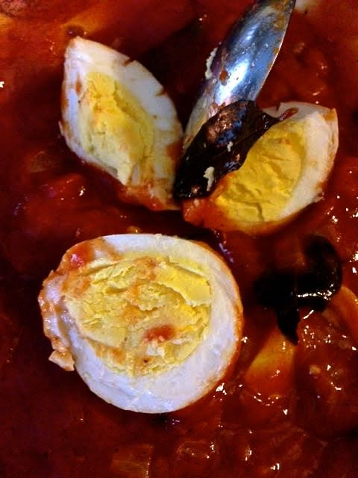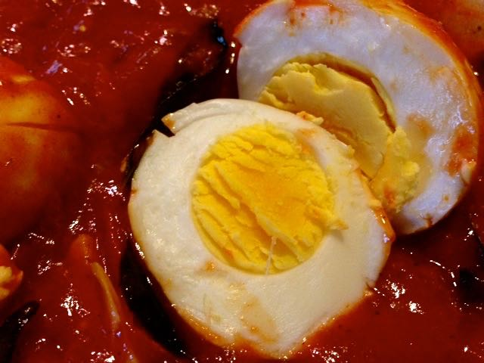

Ingredients:
6 large hard-boiled eggs (3 per serving)
½ cup chopped onion
¼ cup chopped tomato
4 cloves garlic, quartered
2 cups (16 ounces) tomato sauce
2 tablespoons vegetable oil
3 slivers cinnamon stick, or a very short stick or ⅛ teaspoon ground cinnamon
¼ teaspoon fenugreek seeds
¼ teaspoon cumin seeds
¼ teaspoon fennel seeds
¼ teaspoon ground turmeric
1 teaspoon curry or sambhar powder
½ - 1 teaspoon ground cayenne pepper
¼ teaspoon ground cumin
¼ teaspoon ground, black pepper
¼ teaspoon salt
2 tablespoons minced cilantro (optional garnish)
Curry leaves, fresh or dried – as many as you like, or none at all

Preparation:
Bring a large saucepan to medium heat, add the oil; let it come to heat. Add in curry leaves (if including), then the cinnamon, fenugreek seeds, cumin seeds and fennel seeds. Allow to fry until browned, then add the onion. Cook until soft, then add the turmeric. Cook for about a minute, until turmeric is fragrant; add in the tomatoes.

Sauté until tomatoes are soft, then add in the garlic, curry powder, cayenne, ground cumin, black pepper and salt. Pour in the tomato sauce and stir well. Bring to a light simmer for about 4 minutes (if sauce is too thick for your liking, add a little hot water). Fish out any cinnamon sticks and discard.

Cross-hatch the eggs with a paring knife on both ends and add them into the sauce. Simmer for 10 minutes, frequently spooning sauce over the eggs. Close the fire, cover the pot and let eggs stand for 10 minutes before serving so that they fully absorb the sauce.

