Dal Soup

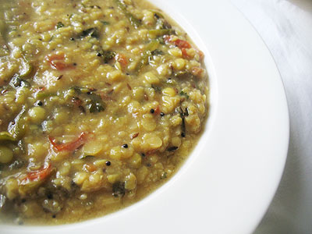 Recipe makes 4 servings.

INGREDIENTS:
- 2 tablespoons oil
- 1 tablespoon chopped fresh garlic
- 2 tablespoons garam masala
- 1 tablespoon cumin seeds
- 1 teaspoon turmeric
- 1 cup chopped tomatoes (I use a can of San Marzanos, crushed by hand)
- 1 cup lentils
- 5 cups water
- ¼ teaspoon salt and freshly ground black pepper
- Few fresh coriander leaves/sprigs, for garnish

DIRECTIONS:

Heat the oil in a skillet over medium-high heat until it begins to get hot. Add the garlic, garam masala, cumin seeds, and turmeric and cook for 20 seconds. Add the tomatoes and cook for 2 minutes. Add the lentils and water and bring to a boil. Turn the heat to low and cook until the lentils are tender, about 30 minutes. Serve in a bowl and garnish with fresh coriander sprigs.

