CuiMan’s Chinese Ribs Recipe

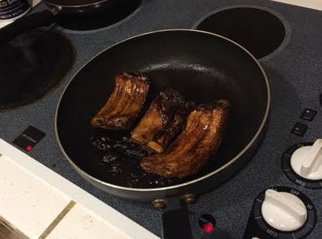

This is an authentic Chinese recipe from the wife of my old friend in Seattle. She uses pork ribs, but says any kind of ribs can be used in this recipe.

