Crispy Salt & Pepper Chicken for Two (paper-wrapped, Chinese street food)

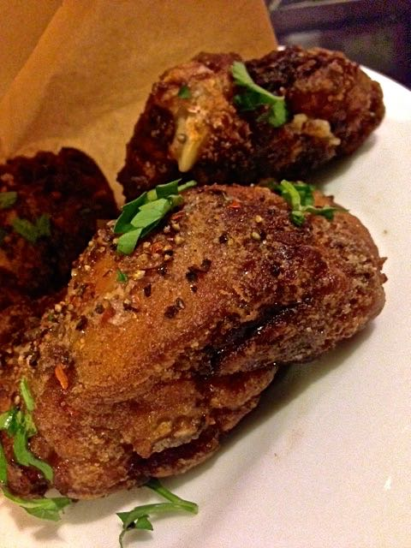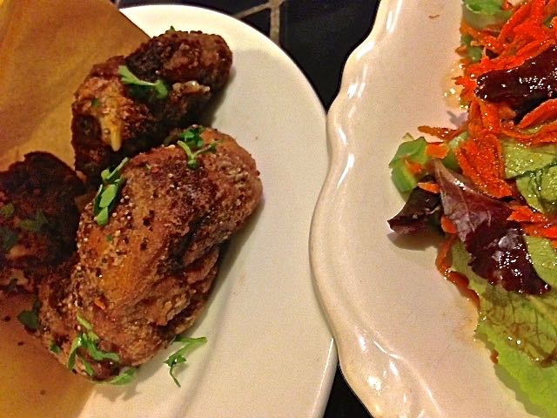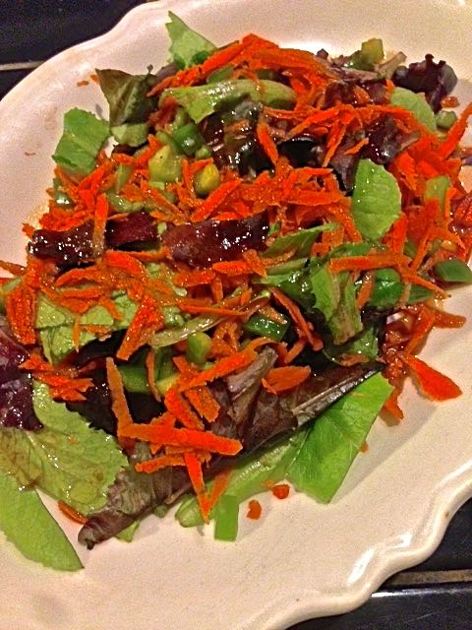

Ingredients:
4 skinless chicken thighs, each piece chopped in half across the bone (see notes)
2 teaspoons soy sauce
1 heaping teaspoon Chinese five-spice powder (see notes)
¾ teaspoon salt, plus more for seasoning
1 clove garlic, smashed
¾ teaspoon toasted sesame oil
2 heaping tablespoons cornstarch, for dusting
Vegetable oil, for frying
1 heaping teaspoon ground, black pepper
Fresh cilantro, chopped and/or crushed red-pepper flakes (optional, for garnishing)
Mixed Salad, for serving, recipe follows

Special Equipment: Parchment paper (see notes)

Preparation:
Mix together the soy sauce, five-spice powder, sesame oil, salt and garlic. Put the chicken in a Ziploc bag and pour the mixture in over it, coating the chicken well. Let marinate for as much time as you have; for best results, leave the chicken in the refrigerator at least 6 hours, but preferably overnight.
When ready to fry, toss the chicken pieces in the cornstarch (I do it in a paper bag).
Heat enough the vegetable oil that will completely submerge the marinated chicken pieces in a large saucepan over high heat to 350° F. Add the chicken and fry lightly until the thighs are golden brown on all sides and cooked through, 6 to 8 minutes. The chicken should read at least 175° F. on a meat thermometer to be cooked all the way through. Drain the chicken on paper towels and season them with plenty of salt and pepper.
Cut the parchment into 8” to 10” squares. Per serving, wrap two pieces of parchment into a cone shape and secure with a piece of tape (see notes). Put 4 pieces of chicken in each cone and garnish with chopped cilantro and a sprinkling of crushed red-pepper flakes.

Serve with chips and a good, cold beer alongside a platter of Chinese mixed salad. For the salad, you’ll need:

1 tablespoon olive oil
1 tablespoon soy sauce
1 tablespoon rice vinegar
1 teaspoon toasted sesame oil
1 head butter or red leaf lettuce, sliced
2 carrots, peeled and shredded
1 medium Fresno chili, stemmed, seeded and finely chopped
½ scallion, green parts only, finely chopped

Preparation:
In a small bowl, whisk together the olive oil, soy sauce, rice vinegar, and toasted sesame oil; set aside.
Toss the lettuce, carrots, chilis and scallions with the dressing when ready to serve.

Notes:
It's not always super easy to cut the thigh pieces in half with the bone, so I just have my butcher do it for me. I get a weird/blank stare back, but not after I explain it. Using a Chinese cleaver definitely does the trick. But with a large chef’s knife and a little extra pressure, it’s totally do-able!

Chinese five-spice powder contains cinnamon, cloves, star anise, Szechuan peppercorns and fennel. It’s really aromatic, warming and spicy.

Traditionally, this chicken was served in newspaper-wrapped parchment cones (with the parchment lining the interior of each newspaper cone, like in the picture below). But I just use parchment because I can’t stand getting my hands and fingers dirty with the black newsprint.

