Chinese-Restaurant-Style Chicken Curry for Two

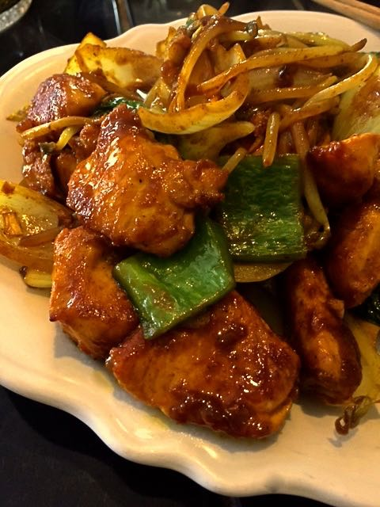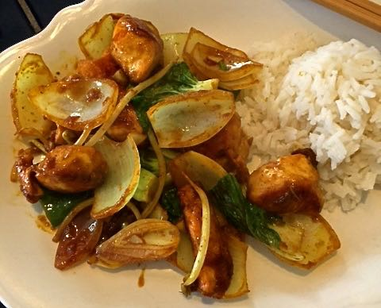

Ingredients:
1 boneless, skinless chicken breast, cubed into 1½” - 2” pieces
1 teaspoon brown sugar
1 tablespoon soy sauce, plus more for seasoning
1 tablespoon shaoxing rice wine or dry sherry
1 tablespoon cornstarch
3 tablespoons Asian sesame oil
2 cloves fresh garlic, minced
1 small onion, cut into 1½” - 2” pieces
2 cups vegetables of your choice, such as bok choy, green bell pepper, bean sprouts, scallions, tomatoes – be sure to chop large vegetables into bite-sized pieces
1 – 2 teaspoons yellow curry powder, more to taste
Ground, black pepper, to taste
1 cup cooked Jasmine rice - ½ cup for each serving

Preparation:
Marinate the chicken pieces in a marinade made of the brown sugar, soy sauce, wine and cornstarch for 30 minutes to an hour.

Heat the sesame oil in a 12” non-stick skillet, throw in the marinated chicken and brown on all sides. Add in the chopped onion and garlic and stir-fry until translucent. Add in the remaining vegetables, the curry powder, a dash more soy sauce, black pepper; cook with the chicken over medium-high heat, adding just enough water to make a sauce to help distribute the curry powder.

Stir constantly to prevent sticking. Cook until chicken is cooked through and serve immediately with ½ cup of the rice per each serving.

