Takeout-Style Chinese Pork Ribs for Two

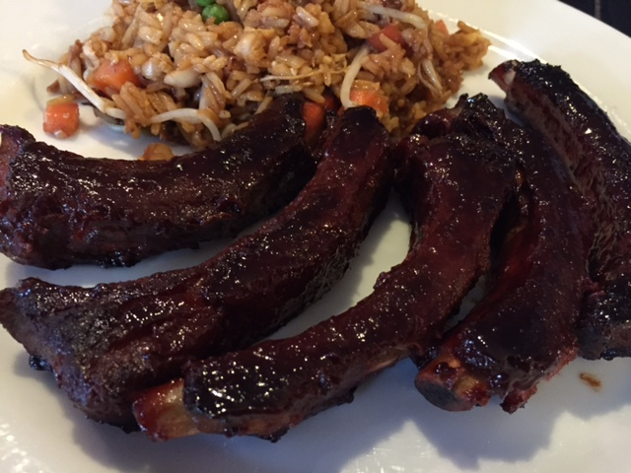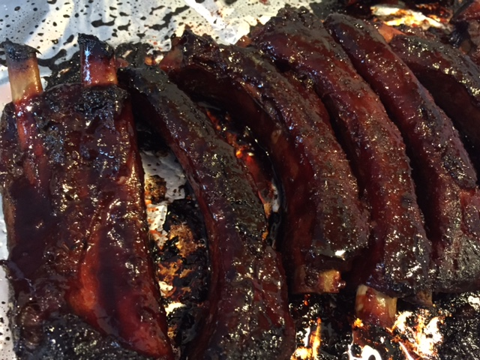

Make those savory red, Chinese-restaurant ribs at home yourself!

Ingredients:
1 rack spare ribs or baby-back ribs, individually sliced into single ribs
¼ cup hoisin sauce
4 tablespoons soy sauce
4½ teaspoons brown sugar
1 tablespoon honey, plus a bit extra to finish
1½ teaspoons Chinese five-spice powder
½ teaspoon granulated garlic powder
½ teaspoon grated fresh ginger (I use Indian ginger paste)
½ teaspoon red food coloring

Preparation:
Mix together the hoisin sauce, soy sauce, brown sugar, honey, five-spice powder, garlic, ginger and food coloring in a measuring cup. Pour the marinade into a large Ziploc bag, reserving ¼ cup for basting later. Add the ribs to the bag and marinate, refrigerated, for at least 3 hours, though overnight is best.

Pre-heat oven to 350° F. Place ribs on a foil-lined baking sheet, tent the ribs with more foil and place them in the oven for an hour. After an hour, remove the foil and flip the ribs with tongs. Cover them back up with the foil; bake another 45 minutes.

Next, uncover the ribs and brush them well with ¼ of the reserved sauce. Flip them and brush another ¼ of the sauce on the other side. Cover with the foil and bake for 15 minutes. Turn off the oven, uncover the ribs, brush the remaining sauce on all sides, cover them back up with the foil and let them rest in the cooling oven a final 10 minutes, or until ready to serve.

