Crispy-Fried Chinese Salt & Pepper Shrimp for Two

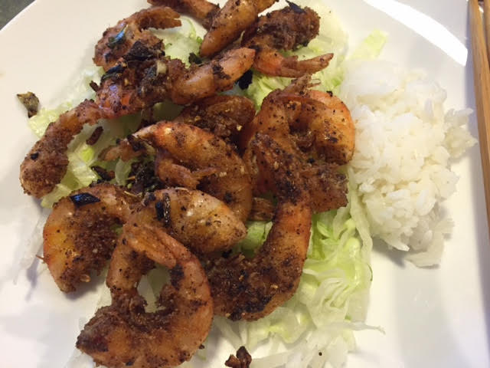 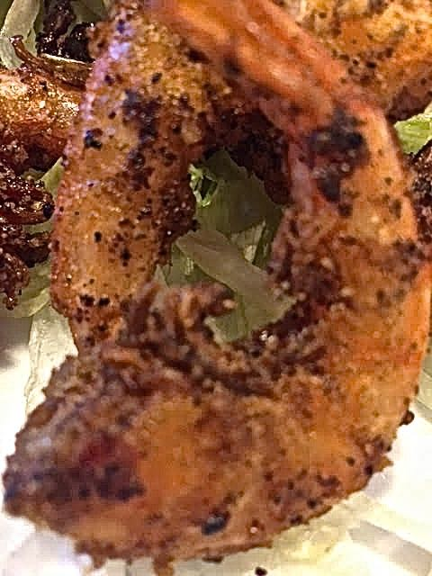 You eat these fried shrimp shells and all!

Ingredients:
¾ pound shell-on shrimp (40 – 50 per pound – don’t make this with larger shrimp)
½ cup shaoxing rice wine or dry sherry
1¼ teaspoons black peppercorns
1 teaspoon Sichuan peppercorns
1 teaspoon sugar
¼ teaspoon cayenne pepper
2 cups vegetable oil
5 teaspoons cornstarch
3 garlic cloves, minced
1½ teaspoons grated fresh ginger
1 scallion, sliced thin on bias
½ head iceberg lettuce, shredded (about ¾ cup per serving)
Salt

Preparation:
Adjust the oven rack to middle position and preheat oven to 225° F. Dissolve 1 teaspoon salt in the rice wine, then marinate the shrimp in it for 15 minutes. Meanwhile, coarsely grind the black and Sichuan peppercorns in a spice grinder. Mix with the sugar and cayenne.

Heat the oil in a wok or large skillet over medium-high heat until oil registers 385° F. While the oil is heating, drain the shrimp and pat dry with paper towels. Combine the cornstarch and 1¾ teaspoons (half) of the peppercorn mixture, then toss the shrimp with it until they’re thoroughly coated. Let them sit a few minutes.

Carefully add the coated shrimp to the oil and deep fry, stirring to keep them from sticking together, until light brown, 2 to 3 minutes. Using a wire skimmer or slotted spoon, transfer them to a wire rack set in a foil- or parchment-lined baking sheet in the preheated oven. Remove all but 2 tablespoons oil from the wok or skillet.

When ready to serve, bring the remaining oil in the wok or skillet to medium-high heat. Add the garlic, ginger, remaining peppercorn mixture and scallions; stir-fry until the mixture is fragrant and just beginning to brown. Add the deep-fried shrimp and stir-fry until coated with the mixture. Line a couple of plates with shredded lettuce, top with shrimp stir-fry and serve immediately with steamed jasmine rice.

