Chinese-Style Pork Kabobs for Two

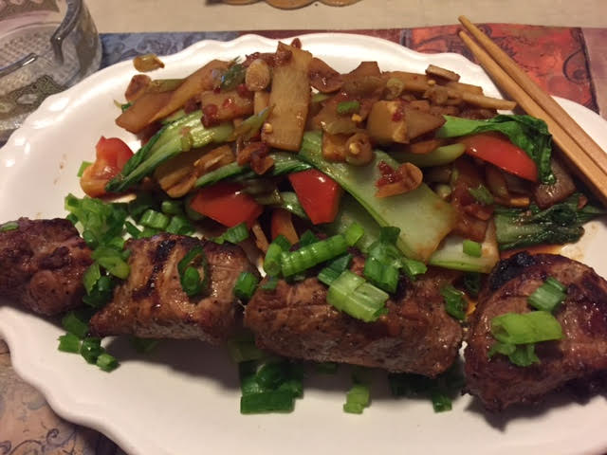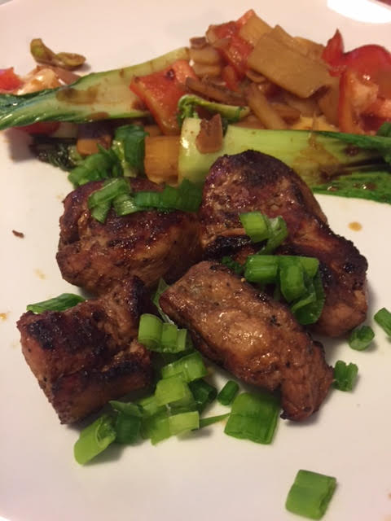

Five-spice powder and hoisin sauce give these kabobs the true flavor of China! The correct way to eat kabobs in China is to first remove the meat onto your plate from the skewers with your chopsticks.

Ingredients:
1 pork tenderloin, trimmed of all silver skin (I have the butcher do it)
2 tablespoons hoisin sauce
2 scallions/green onions
¾ teaspoon Chinese five-spice powder
½ teaspoon regular table salt
½ teaspoon granulated garlic powder
½ teaspoon soy sauce
¼ teaspoon ground black pepper
¼ teaspoon cornstarch

Preparation:
Make a Chinese BBQ sauce by whisking together the hoisin sauce, five-spice powder, salt, garlic powder, soy sauce, black pepper and cornstarch together in small bowl.

Cut the tenderloin in half, then cut each half in two, then cut each remaining piece in half so that you have 8 pieces. Mix the pork pieces and the sauce mixture together in a big bowl, thoroughly coating the pork with the mixture. Let the pork marinate in the sauce for at least 30 minutes (I put it in a quart Ziploc to marinate).

Thread the pork onto two 12” metal skewers, 4 pieces each skewer, leaving ¼“ between pieces (I wear washed latex gloves to do it). Grill or broil the skewers until the meat is well browned. Transfer to a serving platter, tent loosely with aluminum foil, and let rest for 5 minutes. Sprinkle with scallions and serve with stir-fried vegetables and steamed rice on the side.

