Chinese Garlic Spinach for Two

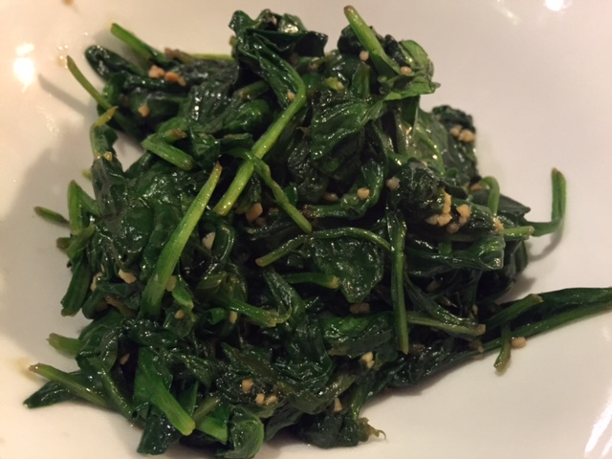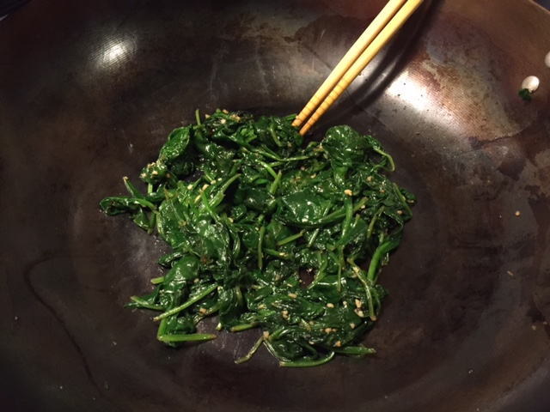

This is served as a simple side dish in China.

Ingredients:
1 tablespoon peanut oil
2 cloves garlic, finely chopped
Two 6-ounce bags baby spinach leaves
Pinch sea salt

Preparation:
In a wide pan or wok, heat the peanut oil over medium-high heat. Add the garlic and sauté until fragrant.

Add the spinach leaves and toss with tongs or chopsticks until wilted (adding a splash of water to facilitate cooking, if desired), 2 to 3 minutes.

