Chinese Braised Short Ribs
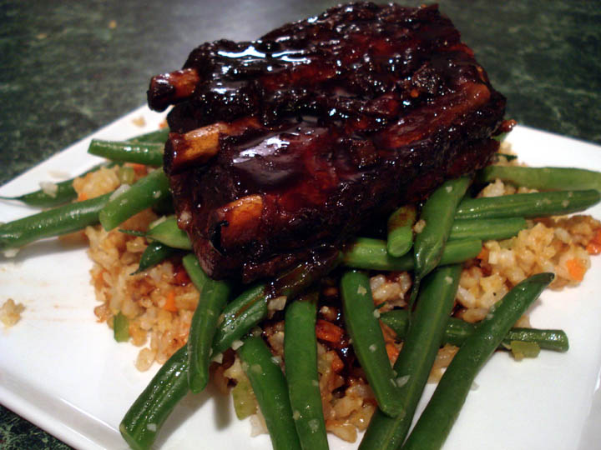 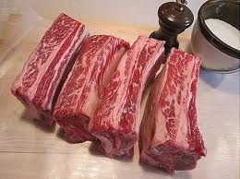 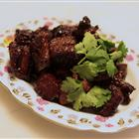 – recipe serves 4.

Ingredients:
5 pounds beef short ribs, cut into 4-ounce portions
1 cup soy sauce
¼ cup rice wine vinegar
3 cloves garlic, peeled and smashed
1 (5-inch) stalk lemongrass, halved and smashed
1 tablespoon peeled and minced ginger
½ cup light brown sugar
1 quart water
½ cup sliced green onion bottoms, white part only
¾ teaspoon crushed red pepper
¼ cup fresh orange juice
¼ cup hoisin sauce
2 tablespoons fresh lemon juice
Jasmine Rice, for serving
2 teaspoons finely grated orange rind, for serving
Sliced green onion tops, optional for garnish

Directions:
Preheat the oven to 350 degrees F.

In a long, wide baking dish, combine the short ribs, soy sauce, vinegar, garlic, lemongrass, ginger, brown sugar, water, green onion bottoms, crushed red pepper, and 2 tablespoons of the orange juice. Make sure that the baking dish is shallow enough so that the short ribs are submerged in the liquid.

Bake the short ribs, covered with foil, for about 3 hours, or until the meat is tender and falling off the bones. Remove the short ribs from the braising liquid and cover with the foil to keep warm. Increase the oven temperature to 425 degrees F.

Drain the fat off of the cooking liquid and discard. Place the remaining braising juices in a medium saucepan with ¼ cup of the hoisin sauce and bring to a boil over medium-high heat. Reduce the liquid until only about 1¼ cups remain. Strain through a fine-meshed strainer, discarding the solids. Stir in the remaining 2 tablespoons of orange juice and the lemon juice.

Return the short ribs and the reduced sauce to the baking dish, coating the short ribs well with the sauce. Bake for 10 minutes, until the short ribs are heated through and slightly glazed. Serve hot over jasmine rice. Season each portion with the orange zest and garnish with the green onions if desired.

