Chinese Beef with Broccoli Stir-Fry for Two

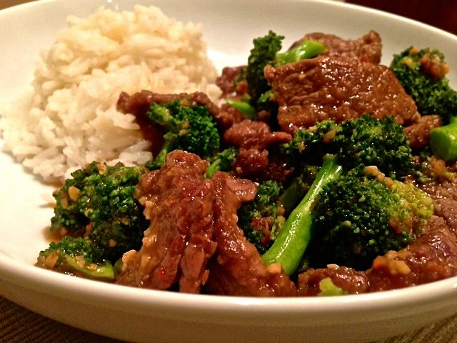

Ingredients:
½ pound beef flank or skirt steak, thinly sliced across the grain
1 tablespoon minced garlic
2” knob ginger, peeled and finely grated
2 teaspoons Chinese black vinegar (may substitute with balsamic vinegar)
1 tablespoon soy sauce
1½ teaspoons hoisin sauce
1½ teaspoons orange blossom honey
2 tablespoons Asian sesame oil, divided
2 tablespoons cornstarch
1 large head broccoli, cut into florets
¾ teaspoon red-pepper flakes, or more (to taste)
2 servings steamed, jasmine rice, for serving

Preparation:
Combine the garlic, ginger, vinegar, soy sauce, hoisin sauce, honey and red-pepper flakes (if including any) into a sauce. Mix well and set aside.

Blanch the broccoli. Place the broccoli in a large-enough saucepan (I just do it in my wok), cover with water, lightly salt the water and bring to a boil for 30 seconds. Strain the blanched broccoli in a colander and rinse thoroughly with cold water. Set aside to drain.

Preheat a wok or a large skillet. Once it has reached a medium heat, add ½ of the sesame oil. Dust the beef with the cornstarch, lightly shake off any excess cornstarch and add the beef to the pan (I like to shake the beef and cornstarch together in a paper bag). Cook for 2 to 3 minutes. Add the broccoli to the pan and shake frequently.

Add the sauce and stir to evenly coat the beef and broccoli. Cook until the sauce thickens about 5 minutes. Serve immediately with steamed jasmine rice.

