Lamb or Chicken Saag

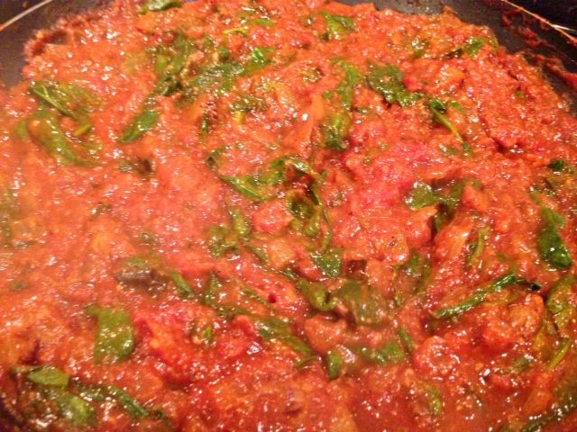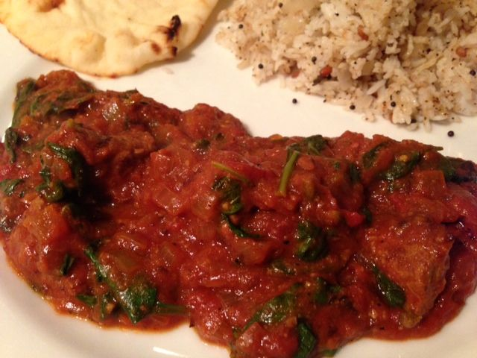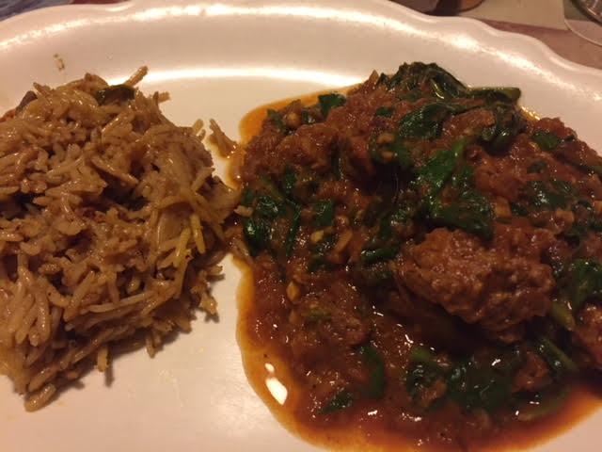

Ingredients:
½ pound chicken or lamb stew without bones and trimmed of fat, cut into 2” pieces
2 tablespoons oil
1 bay leaf
2 to 4 slivers cinnamon, or 1 teaspoon ground
2 to 4 curry leaves (optional) – dried are fine
¼ teaspoon fenugreek seeds
1 teaspoon cumin seeds
¼ teaspoon fennel seeds
1 teaspoon urad dal
1 medium-sized onion, diced
1 cup minced tomato (I use a 15-ounce can of Italian tomatoes, crushed by hand)
6 - 8 cloves minced garlic, or 6 – 8 teaspoons Indian garlic paste
3 tablespoons fresh minced ginger, or Indian ginger paste
½ teaspoon turmeric powder
2 teaspoons curry powder
½ teaspoon cayenne
½ teaspoon black pepper mixed with ½ teaspoon ground cumin powder
½ cup tomato sauce
½ teaspoon salt
5 ounces chopped fresh baby spinach

Preparation:
Heat oil in a saucepan over medium-high heat. Brown the meat and set aside. To the hot oil, add bay leaf, cinnamon and curry leaves into oil. Add fenugreek, cumin, fennel seeds, and urad dal. Stir-fry until urad dal turns golden. Immediately add onion, tomato, garlic, and ginger. Add turmeric and cook until onions are tender.

Increase heat to medium-high. Add back the meat and stir for 3 to 5 minutes until meat is coated with turmeric mixture. Add curry powder, cayenne powder, black pepper and cumin powder. Stir and mix the powders well into meat. Add tomato sauce and salt. Cook and stir for another 2 minutes. Add 2 cups of water.

When mixture begins to boil, reduce heat to medium-high. If cooking in saucepan, cover and cook about 20 - 30 minutes, stirring often, until meat is tender. Additional tomato sauce and water can be added, about ¼ cup at a time, if the sauce becomes too thick or if the meat is not yet tender. Add fresh baby spinach to the saucy dish. Stir well into meat mixture. Serve warm with steamed basmati rice and lots of Indian flat bread.

