Chicken Tikka Masala. The national dish of Great Britain! Recipe serves two.

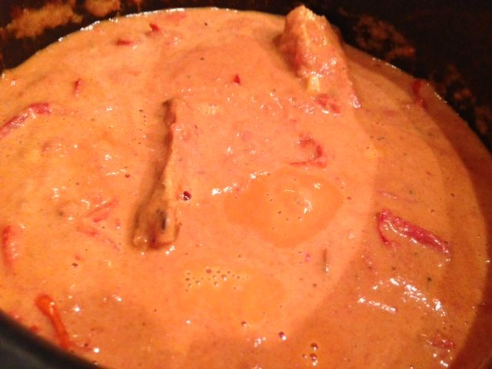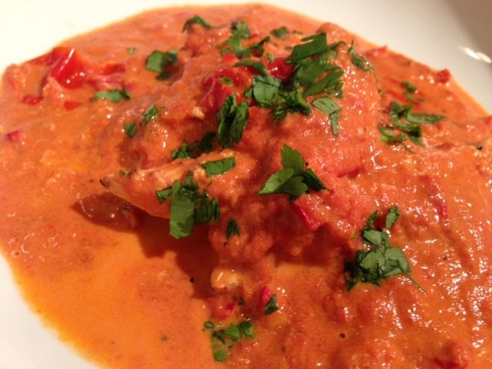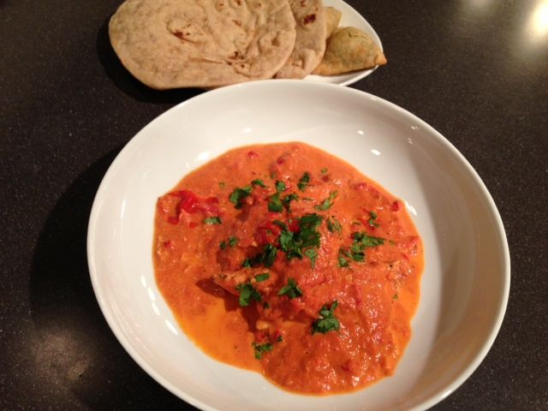

Ingredients:
Chicken & Marinade
8 oz. boneless chicken breasts, skins removed and cut into bite-sized pieces
6 oz. thick, natural yogurt (plain)
2 teaspoons fresh ginger, minced
1 teaspoon ground cumin
½ teaspoon ground cinnamon
1 teaspoon cayenne powder
1 teaspoon each salt and cracked black pepper
Tomato Gravy
14 oz. canned cocktail tomatoes
4 oz. heavy cream
2 garlic cloves, minced
1 - 2 red chilies, finely chopped
1 teaspoon each ground cumin and paprika powder
1 tablespoon ghee or clarified butter
a handful of coriander leaves/cilantro, chopped
salt and pepper

Preparation:
Mix all of the ingredients for the marinade. Thoroughly coat the chicken in it, cover and refrigerate 2 hours, or overnight. To cook, grill or broil the chicken on a wire wrack set in a sheet pan evenly on all sides, until juices run clear, 5 - 6 minutes.

Heat a small saucepan over to medium heat. Melt the ghee/butter and sauté the garlic with the chilies until fragrant. Sprinkle the ground cumin, paprika powder and a pinch of salt. Sauté for a further minute or two until the mixture turns into a paste-like texture. Pour in the canned tomatoes, scraping the bottom of the pot to deglaze it. Simmer, uncovered, for 10 - 15 minutes on low heat until the sauce begins to thicken, then add the grilled chicken pieces and cream. Simmer for another 10 minutes, thickening the sauce further and to heat the chicken and cream through.

Sprinkle with freshly chopped coriander leaves and serve over steamed Basmati rice, with Indian flatbread and pickles.

