Chicken Satay with Peanut Sauce – recipe make 6 skewers (3 per serving)

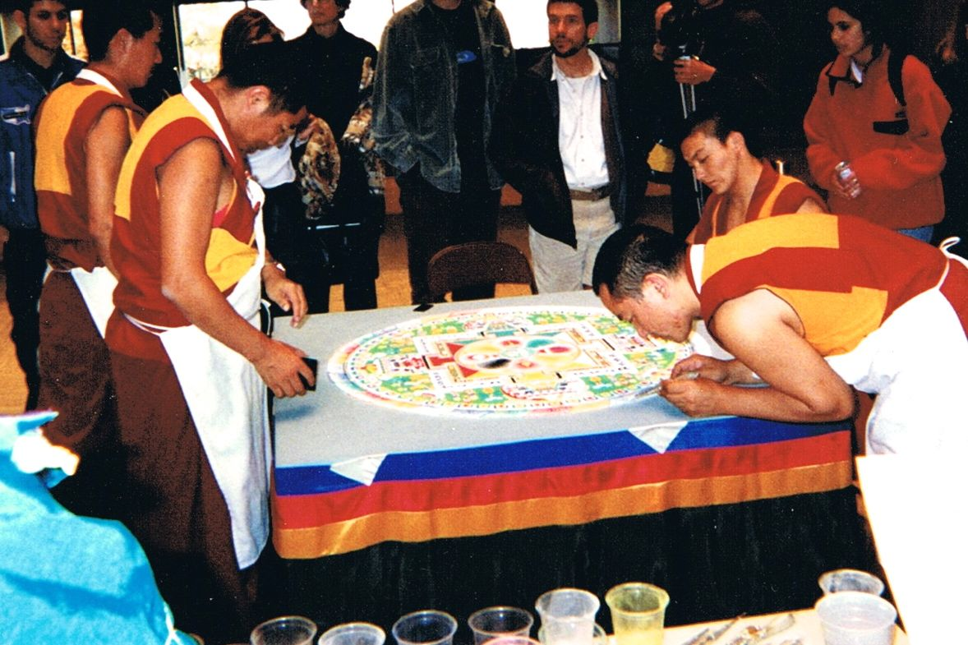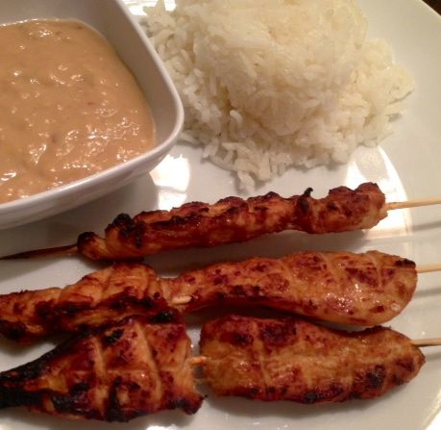

Ingredients:

For the Chicken
½ pound skinless, boneless chicken (any kind you like), cut into long strips
1 large clove garlic, minced
1”-long piece fresh ginger root, finely grated
1½ teaspoons fish sauce or 1 tablespoon soy sauce

For the Sauce
3 ounces coconut milk
3 tablespoons natural peanut butter – not Jif or Skippy!
1 very small onion (about 1 ounce), very finely grated or whizzed in food processor
¾ teaspoon soy sauce
½ teaspoon brown sugar
¼ teaspoon red pepper flakes

Preparation:
Soak 6 wooden skewers at least 30 minutes in cold water. Mix together the garlic, ginger, and fish or soy sauce. Thoroughly coat the chicken with the mixture and allow to marinate in refrigerator, covered, for 1 hour (I just throw it all in a plastic Ziploc bag).

For the peanut sauce: In a small saucepan over medium heat, combine coconut milk, peanut butter, onion, soy sauce, brown sugar, and pepper flakes. Bring to a boil, stirring frequently. Remove from heat, cover and keep warm until ready to serve.

Preheat grill on medium-high heat and lightly oil grate. Or you can line a baking sheet with parchment paper or foil and place a greased wrack on it under your oven broiler. Thread chicken onto skewers. Grill or broil chicken skewers until nicely browned and no longer pink in the center, about 6 minutes per side.

Serve with warm peanut sauce and cooked, jasmine rice.

