Chicken or Beefsteak Masala - recipe serves 2.
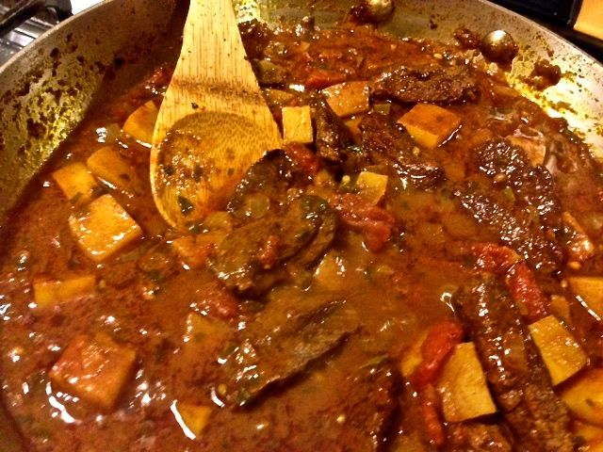

Ingredients:
1 tablespoon vegetable oil
1 small onion, finely chopped
1 tablespoon Indian garlic paste
1 tablespoon Indian ginger paste
1 green chile, finely chopped
1½ teaspoons coriander seeds, slightly crushed between your palms
½ teaspoon fenugreek seeds
½ tablespoon garam masala
½ teaspoon Spanish paprika
½ teaspoon turmeric
½ teaspoon salt
1½ teaspoons tomato paste
8 ounces chicken thighs, boneless/skinless, or skirt steak, sliced
8 ounces tomatoes, chopped (I use canned, Italian San Marzano, crushed by hand)
8 ounces red potatoes, chopped (do not peal)
¼ cup loosely packed fresh cilantro leaves
1 – 2 cups water (1 for thick sauce, 2 for nice, soupy sauce)

Preparation:
Put oil in a large saucepan over medium-high heat. Brown chicken or steak and set aside.

Add a little more oil and then the onion, garlic, ginger, and chili; sauté for 3 minutes, or until the onions are softened. Add the coriander seeds, garam masala, paprika, turmeric, and salt and toast for 10 seconds and then add the tomato paste.

Stir well, then add the chicken thighs or steak, turning frequently as it cooks. Add the tomatoes, potatoes, cilantro, and water and mix well. Bring the mixture to a boil and then reduce the heat to a simmer.

Cover with a lid and let cook for about 20 to 25 minutes, or until the chicken is cooked through and potatoes are fork tender. Serve the masala with boiled rice.

