Chicken Chow Mein for Two (Chinese “fast food!”)

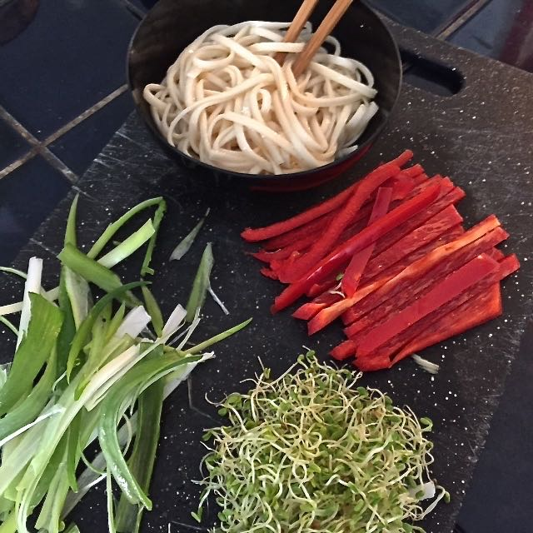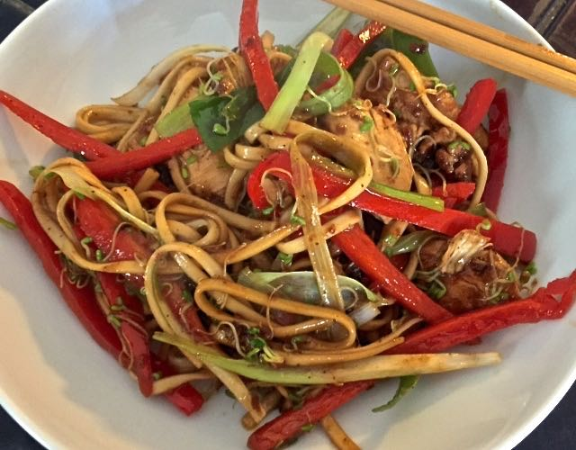

In Mandarin, the word chow means “stir fry” and mein means “noodles.”

Ingredients:
5 ounces dried, long, thin Asian yellow wheat flour noodles or medium egg noodles
1 skinless/boneless chicken breast, sliced into strips or bite-sized pieces
1 red bell pepper, seeded and julienned into narrow sticks
1 large scallion, cut in half and sliced lengthwise, both white and green parts
5 ounces bean sprouts
1 heaping teaspoon Chinese five-spice powder
1 teaspoon chili/hot sauce, optional
1 tablespoon cornstarch
2 tablespoons peanut oil
1 teaspoon toasted sesame oil, or to taste
4 tablespoons soy sauce
Ground black pepper, to taste

Preparation:
Season the chicken with a couple of tablespoons of soy sauce, the five-spice powder, and chili sauce, if using. Mix well and let marinade for 30 minutes (I do it in a Ziploc bag) at room temperature.

While the chicken marinates, boil the noodles until al dente, or as per the package instructions. Drain, then run them under cold running water, and drain again. Drizzle with a few splashes of sesame oil, and toss through to prevent them from sticking.
Coat the marinated chicken pieces lightly with the cornstarch – I shake them all together in a paper bag. Heat a skillet over high heat, add peanut oil, heat until smoking; add the chicken and stir-fry for 2 – 3 minutes, or until cooked through.
Add the red bell pepper, and stir-fry for 1 minute, then add the bean sprouts and scallion and stir-fry for less than 1 minute. Add the cooked noodles, and season with the remaining soy sauce, toasted sesame oil, and black pepper, to taste. Stir well and serve immediately.

