Chinese Cashew Chicken for Two

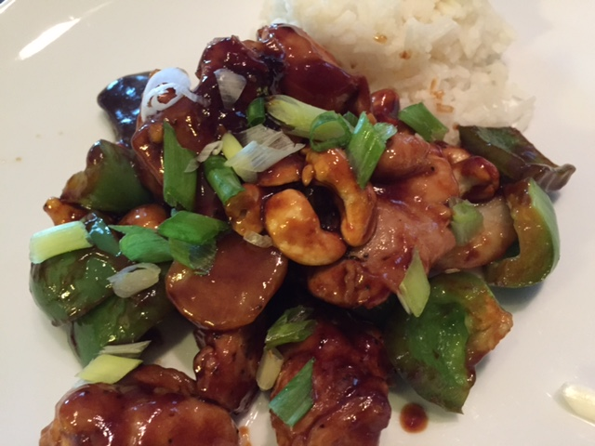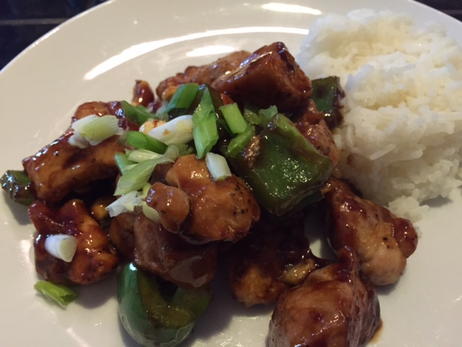

Ingredients:
2 boneless, skinless chicken thighs, cut into small cubes
1½ teaspoons rice vinegar
1½ teaspoons brown sugar
1½ teaspoons oyster sauce
¼ teaspoon sesame oil
¼ cup soy sauce (8 tablespoons, divided in half)
4½ teaspoons chopped fresh ginger
Salt and ground, black pepper
4½ teaspoons sesame oil
2 cloves garlic, minced
1 green bell pepper, cut into small cubes
4 tablespoons Shaoxing rice wine or dry sherry
1 tablespoon cornstarch
½ cup whole roasted, unsalted cashews
1 5-ounce can sliced water chestnuts
1 scallion, thinly sliced, for garnish

Preparation:
In a bowl, combine the vinegar, brown sugar, oyster sauce, the ¼ teaspoon sesame oil, 4 tablespoons of the soy sauce and 1½ teaspoons of the ginger. Set aside.

Season the chicken with salt and pepper. Heat the 4½ teaspoons sesame oil in a large non-stick skillet over medium-high heat. Add the chicken and sauté until cooked through, 5 to 7 minutes.

In the same skillet, stir-fry the garlic, bell peppers and remaining 1 tablespoon ginger, keeping them crisp-tender. Deglaze the skillet with the wine/sherry and scrape up any brown bits. Add the reserved soy mixture and cook until the mixture boils, about 1 minute. Whisk together the cornstarch and remaining 4 tablespoons soy sauce in a small bowl, then stir the slurry into the skillet. Add the cashews and water chestnuts. Add 4 tablespoons water to thin the sauce. Cook for another minute. Serve garnished with the scallions.

