Brussels Sprouts Kulambu – recipe serves 2.

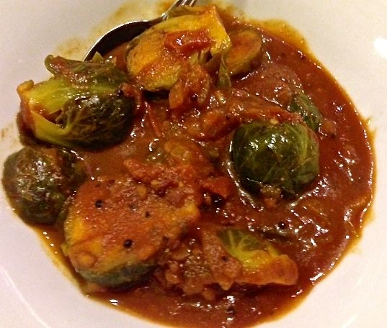 Saucy and delicious, one of my favorites!

Ingredients:
2 tablespoons vegetable oil
¼ teaspoon asafoetida powder
4 to 6 curry leaves (optional)
¼ teaspoon fenugreek seeds
1 teaspoon black mustard seeds
1 teaspoon urad dal
½ cup chopped onion
½ cup chopped tomato
¼ teaspoon turmeric powder
2 teaspoons sambhar powder
1 cup tomato sauce
1 teaspoon each salt and ground, black pepper
1 teaspoon tamarind paste
1 pound (16 ounces - about 20) fresh Brussels sprouts, cut in half

Preparation:
Place oil in a large saucepan over medium heat. When the oil is hot, but not smoking, add asafoetida, curry leaves, fenugreek, mustard seeds, and urad dal. Cover and fry over medium heat until the mustard seeds pop and urad dal is golden brown.

Add onion, tomato, and turmeric powder to hot oil, stirring constantly.

Add sambhar powder, tomato sauce, salt and black pepper. Stir well. Add 2 cups of warm water to saucepan. Stir and cook for few minutes. Add tamarind paste and mix all the ingredients thoroughly.

When the mixture in saucepan begins to boil, add Brussels sprouts. Cover and cook over low heat until Brussels sprouts are just tender (about 15 minutes). Be careful not to overcook.

