Indian Black Pepper and Cumin Rice with Cashews (serves 2)

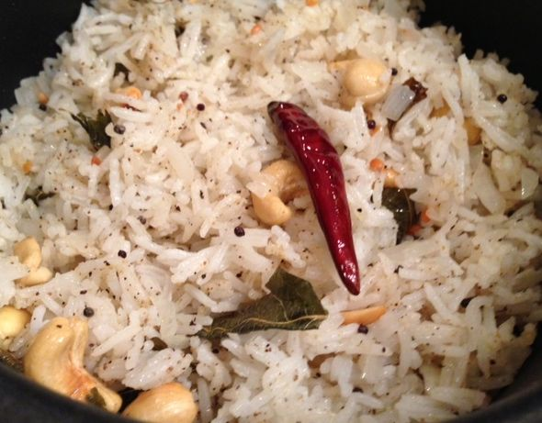

Ingredients
½ cup basmati rice
1 tablespoon vegetable oil
2 to 4 curry leaves (optional)
2 dried red chili peppers
½ teaspoon black mustard seeds
½ teaspoon urad dal
¼ cup (2 ounces) yellow onion, finely chopped
½ teaspoon ground, black pepper
½ teaspoon cumin powder
⅛ teaspoon salt – the rice is cooked with salt and the nuts are also salted
¼ cup whole dry-roasted and salted cashews, peanuts or nut of choice

Directions
Cook rice in 1 cup water with 1 teaspoon vegetable oil and ½ teaspoon salt. Set aside.

Heat oil in a medium-sized skillet or small saucepan over medium-high heat. When oil is hot, but not smoking, add curry leaves and red peppers. Stir briefly. Add mustard seeds and urad dal. Sauté until mustard seeds pop and urad dal is golden brown.

Add onion and cook for only a minute or two – you want the onion to be crunchy in this recipe! Add cooked rice to the onion mixture and stir well with spoon.

Add black pepper, cumin powder, salt and nuts to rice. Mix well.

Cover and keep warm until rest of the meal is ready to be served.

