Bengal Curry

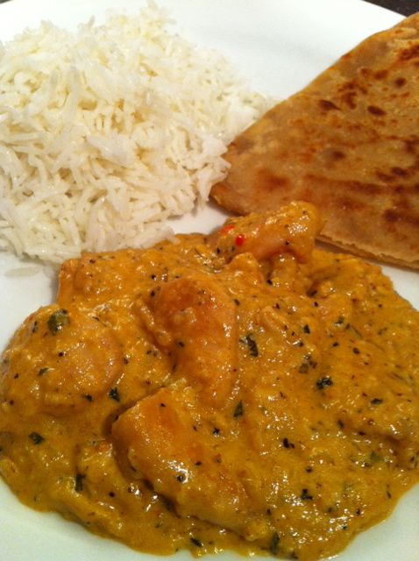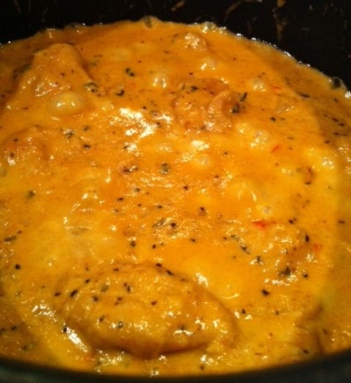
This is rich, decadent East-Indian curry is from an ancient recipe that I found on the backside of a vintage 1950s or ‘60s ad-page that an Etsy seller cut out of an old magazine and included in an order for me. It originally called for two 3-pound chickens to serve 8, but I’ve cut it down to two servings.

INGREDIENTS:
½ pound chicken, cut into bite-sized pieces
1 tablespoon ghee (melted butter) or vegetable oil
1 very small onion (about 2 oz.), finely chopped
1 tablespoon crystallized ginger (about 2 big pieces), thinly sliced – the recipe says that you may substitute 1/4 teaspoon powdered ginger
¼ teaspoon sugar
¾ teaspoon salt & ½ teaspoon ground, black pepper
1 whole clove
1½ teaspoons curry (sambar) powder
a sprig’s worth of fresh mint leaves, finely chopped, or ¼ teaspoon dried mint
2 – 3 red chili peppers, finely chopped
1 cup milk
½ ounce (1 tablespoon) flaked, unsweetened coconut (readily available in Whole Foods’ bulk section) – if you have to use the sweetened, shredded coconut sold in the baking aisle of your grocery store, put it in your food processor or spice grinder until ground to powder and omit the ¼ teaspoon sugar called for above!
2 tablespoons limejuice (juice of 1 lime)
¼ cup cream

PREPARATION:
Melt the ghee in a medium-sized saucepan. Add in the chicken and fry until golden on all sides. Toss in the chopped onion and cook until limp. Stir in the ginger, sugar, pepper, chili, clove, salt, curry powder and mint. Fry for just a minute or so.

Pour in the milk; simmer on medium heat until the chicken is done and the sauce reduced almost completely, about 20 minutes. Stir in the coconut, limejuice and cream; simmer uncovered on medium heat until the sauce is reduced by at least half.

Serve with steamed, basmati rice. This old recipe also suggests serving with thinly-sliced bananas sprinkled with lemon juice, crumbled bacon, chutney, hand-chopped, hard-boiled egg, chopped green pepper, chopped peanuts, chopped apple, chopped cucumber and/or kumquats!

