Turkey Roulade (recipe serves 6 – 8)

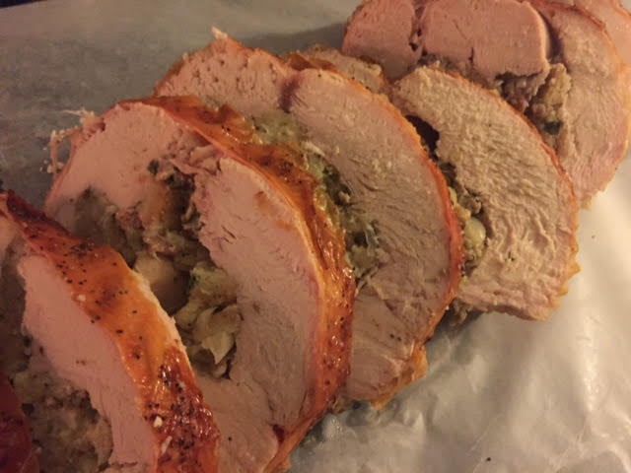

This is what I make for Thanksgiving!

Ingredients:

Roulade
1 stick (8 tablespoons) salted butter, softened
2 ribs celery, diced
1 medium onion, diced
8 ounces bulk pork sausage
3 tablespoons chopped fresh parsley
2 teaspoons chopped fresh rosemary
Salt and ground black pepper
Brandy, for deglazing
2½ cups seasoned dry stuffing mix
1 cup chicken broth
1 large egg
1 boneless skin-on whole turkey breast (approximately 5 pounds), butterflied and flattened

Gravy
¼ cup all-purpose flour
1½ cups chicken broth
½ cup brandy
Salt and ground black pepper

Preparation:
For the roulade: Preheat the oven to 425° F. Place a rack in a baking sheet.

Melt 4 tablespoons of the butter in a large saucepan over medium heat. Add the celery and onions and cook, stirring often, until softened. Add the sausage and cook until browned through. Stir in the parsley and rosemary and cook for about 1 minute. Season with salt and pepper. Deglaze the pot with a splash of brandy, scraping up any brown bits from the bottom. Wipe the pot out and reserve it.

Combine the sausage/veggie mix, stuffing mix, 1 cup chicken broth and egg in a large bowl and stir together. Lay the turkey breast flat and season with salt and pepper. Spread the stuffing mixture in an even layer, then tightly roll the turkey breast. Tie the roll with kitchen twine--approximately 4 to 6 ties evenly spaced.

Rub the remaining 4 tablespoons softened butter all over the surface, sprinkle with salt and pepper and put on the rack in the baking sheet. Roast for 30 minutes, then decrease the oven temperature to 350° F. and continue roasting until the skin is golden brown and crispy and a meat thermometer inserted into the center of the roulade reaches 155° F., another 1 hour to 1 hour 15 minutes. Remove to a cutting board, tent with foil and let rest while you make the gravy.

For the gravy, pour the drippings from the roasting pan into the pot. Bring to medium heat and whisk the flour into the drippings to form a paste and cook, stirring constantly, until the roux is golden brown, about 3 minutes. Add the 1½ cups chicken broth, turn off the heat and add the brandy to the pan. Turn the heat back on and cook, whisking constantly, until the gravy thickens, 5 to 7 minutes. Season with salt and pepper.

Slice the roulade and serve with the gravy!

