Classic Southern-Fried Chicken

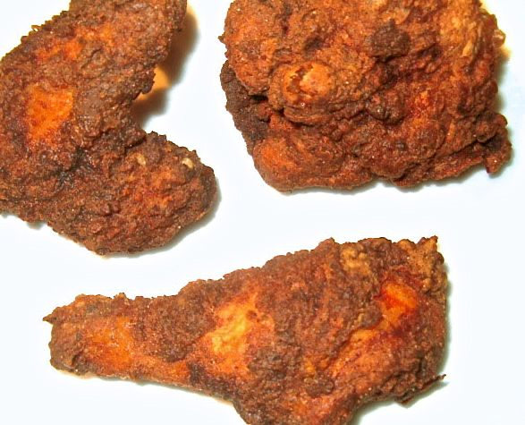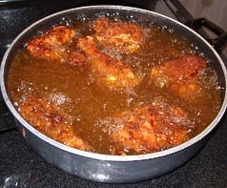

Is there any American dish more popular than this? It was an old favorite in Southern households way before Harlan Sanders and the rest of the fast-food industry seized upon it.

Ingredients:
Chicken parts of your choice - drumsticks/legs, thighs and wings work best (about ½ pound of chicken per serving).
1 pint to 1 quart of buttermilk (enough to marinate all the chicken).
Peanut oil (enough for deep frying)

For the Seasoned Flour
1½ cups all-purpose flour
2 teaspoons granulated garlic powder
2 teaspoons salt
1 teaspoon poultry seasoning
1½ teaspoons ground, black pepper

For the Crispy Batter
⅔ cup all-purpose flour
½ teaspoon salt
⅛ teaspoon ground, black pepper
1 tablespoon cayenne (optional)
2 eggs, beaten
1 quart buttermilk (I use low-fat)
1 cup water (use only ½ cup water for extra-crispy coating)

Preparation:
Marinate your chicken parts overnight in the buttermilk. Make sure you have all the pieces totally submerged in it.

When you're ready to cook, combine the ingredients for the seasoned flour in a medium-sized bowl; set aside.

In a small bowl, combine all the dry ingredients for the crispy batter. In a large bowl, whisk together the egg and buttermilk; gradually add the dry ingredients to it. This batter must not be too thick. If you're using the quantities above, it will turn out just right. If you cut the amount of ingredients to suit the amount of batter that you need for fewer servings (see my tip below), make sure the consistency of the batter is quite thin - add water, if necessary, to make it thin and runny.

Heat oil to 310° F. in a large, deep frying pan/skillet to a depth of about 2 inches. Rinse off the chicken pieces and allow to warm to room temperature. Dip chicken in the seasoned flour, then batter (let it drip off really well), then back into the seasoned flour. Don't let the chicken sit for too long after you've coated it. Lay chicken loosely in the oil, and don't crowd it. Do the larger pieces first. Turn the chicken only once or twice while it cooks. Do not stir; let the oil do the work. Keep a close eye on the oil temperature. If it drops below 260° F., turn the heat up. But the temperature should never exceed 320° F.

The oil will start to slow down and the chicken pieces will float to the top. This means that it's almost done cooking. Using tongs, pull out the chicken piece by piece. Test it for firmness. If the chicken gives a lot, put it back for a couple more minutes. If it doesn't give at all, it's done! Wings will take about 5 - 6 minutes; legs, breasts and thighs around 10 - 15 minutes. Drain on a couple slices of bread or paper towels and allow to stand about five minutes before serving with mashed potatoes (recipe follows), biscuits and coleslaw.

Seal tightly in aluminum foil to refrigerate. Allow the chicken to warm to room temperature before re-heating in 350° F. oven for about 10 minutes.

Note:
Though it's still very fattening to fry food, you are actually doing your heart some good by frying in the peanut oil which is a cholesterol-lowering fat. Remember, moderation is the key word to enjoying things like Southern-fried chicken. So some of this once in a blue moon won't hurt you one bit!

Tip:
Any unused batter may be safely stored frozen and thawed for later use. The amount of the batter mixture that results from using the above measurements makes enough to fry five, 4 - 6 piece meals. I use about a fifth (20%) of the batter immediately to fry four to six pieces for the two of us, and I freeze the rest in a large, plastic freezer-safe container. Later (after it's frozen solid), I thaw the outside of the container with warm water so I can remove the frozen block of batter. It's easy enough to cut into quarter-sections and freeze each section individually in large, freezer Ziploc bags. That way, I have batter ready to thaw for frying up a tasty Southern-fried chicken dinner another four times before I need to make another batch of batter.

