Southern Fried Cabbage (recipe makes 4 servings)

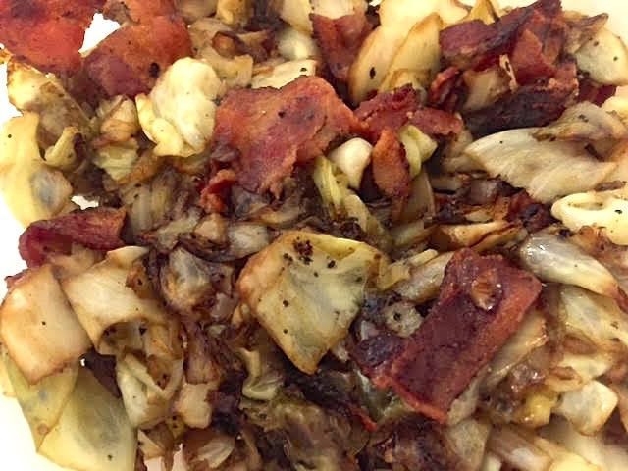

They call it “Southern” fried cabbage, but this recipe sounds as German as can be!

Ingredients:
Half a 16-ounce package of sliced bacon
½ head plain, green cabbage, chopped
½ an onion (or a small one), diced
1 tablespoon Worcestershire sauce
1½ teaspoons apple cider vinegar
1 tablespoon brown sugar
½ teaspoon garlic powder
Salt and ground black pepper to taste

Preparation:
Fry the bacon in a large pot over medium heat until extra crispy. Remove bacon from pot, leaving the grease. Crumble the bacon into bigger pieces after it’s cooled.

In a cup or small bowl, mix the Worcestershire, apple cider vinegar, garlic powder and brown sugar. Set aside.

Add the cabbage to the hot bacon grease in the pot and cook over medium-high heat for 10 minutes, stirring every so often. Add the onion and continue cooking 5 more minutes, still stirring once in a while. Add the Worcestershire mixture. Reduce heat to medium-low and continue cooking for 20 – 30 minutes, still stirring occasionally, until cabbage is tender. Mix in the cooked bacon with the cabbage and season with salt and pepper, to taste.

