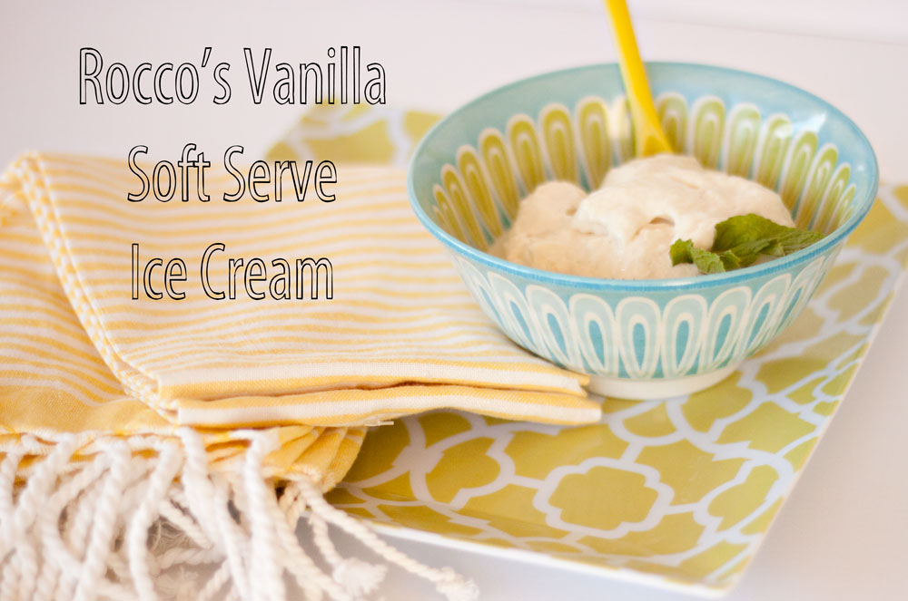

This is Chef Rocco DiSpirito’s quick, easy and delicious alternative to regular ice cream. The recipe is so simple and so amazing! It yields four 4-ounce servings at 79 calories, 2.2 grams fat (1 gram saturated, 0 grams mono, 0 grams poly), 3 miligrams cholesterol, 163 mg sodium, 11g carbohydrate, 2g fiber, 5g protein each serving.

Ingredients:
2 sugar-free, low-fat vanilla pudding snack packs (Jell-O)
6 ounces 2% Greek yogurt (Fage 2%)
8 packets 100% natural stevia powder (Stevia in the Raw – see my notes below)
2 teaspoons xanthan gum
1 cup unsweetened vanilla almond milk (Almond Breeze – see my notes)
1 vanilla bean, split in half lengthwisem (see my notes)
2 teaspoons vanilla extract

Preparation:
First, freeze the pudding and yogurt in their containers until hard, at least 6 hours.

Mix the Stevia and xanthan gum together in a small mixing bowl and set aside.

Pour the almond milk into a blender and scrape the insides of the vanilla bean into the milk. Cover and blend on medium speed for 30 seconds. Add the vanilla extract and turn on the lowest setting. Sprinkle the Stevia and xanthan mixture slowly and evenly directly into the vortex in the blender and blend until thickened, about 30 seconds. Turn off the blender.

Add the frozen pudding and yogurt and blend on high until smooth. Serve immediately.

Notes:
Stevia is just a non-sugar sweetener – I replace it with 2½ teaspoons of Splenda. And I just use regular vitamin-D milk in place of the almond milk. Because the recipe calls for vanilla extract, you can safely leave out the expensive vanilla bean.

