Rice Pudding - a southern favorite (recipe makes 4 servings)

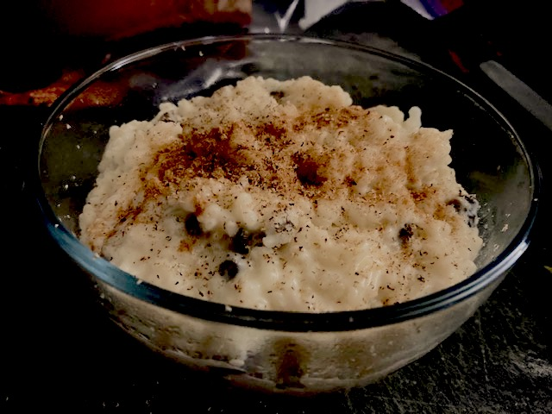

Ingredients:
¾ cup uncooked white rice (for creamier pudding, use short- or medium-grain rice)
2 cups milk, divided
⅓ cup white sugar (sugar substitute Splenda, works great!)
¼ teaspoon salt
1 egg, beaten
⅔ cup raisins, more or less to taste (3 of the little 1-oz. boxes is perfect)
1 tablespoon butter
¼ teaspoon vanilla extract
Ground nutmeg and/or cinnamon, for garnish

Preparation:
Bring 1½ cups water to a boil in a 2-quart saucepan; stir the rice into the boiling water. Reduce heat to low, cover, and simmer for 15 minutes. DO NOT REMOVE THE LID WHILE THE RICE COOKS. Afterwards, remove lid, fluff and let it cool off a bit.

Next, stir 1½ cups of the milk, the sugar, vanilla and salt into the rice. Cook over medium heat until thick and creamy, 15 – 20 minutes. Combine the remaining ½ cup milk, the egg, and raisins in a measuring cup or small bowl and slowly stir that into the rice mixture; cook 2 minutes more, stirring constantly. Remove from heat and stir in the butter.
Eat warm or chill in the fridge before sprinkling with ground nutmeg and/or cinnamon before serving.

