Punch Recipe – Most delicious, Victory Garden Initiative cleaning-party punch (non-alcoholic, makes @ 13 Quarts)

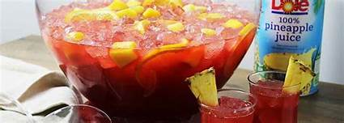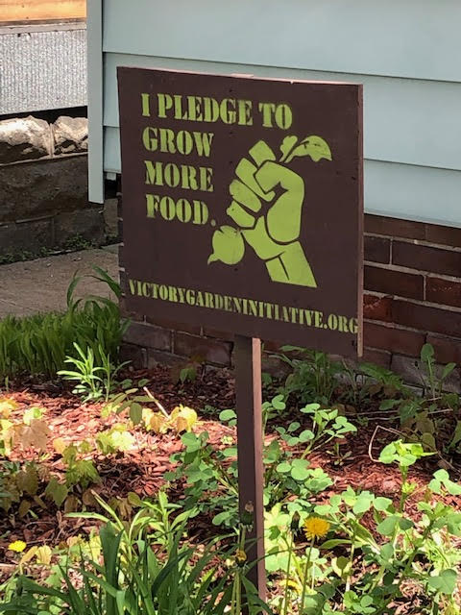

Ingredients:
2 liters cranberry juice
2 liters lemonade
2 liters Ginger Ale
½ a big can (32-ounce) pineapple juice

Preparation:
Mix it all up with plenty of ice!

