Pimento Cheese – a Southern favorite! (Recipe makes about 4 cups.)

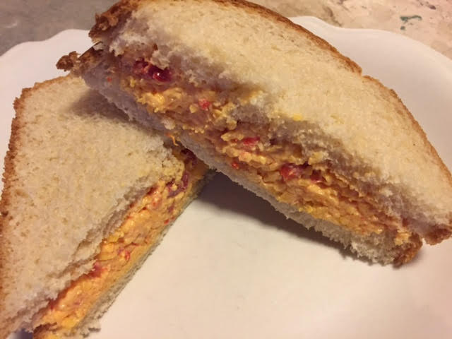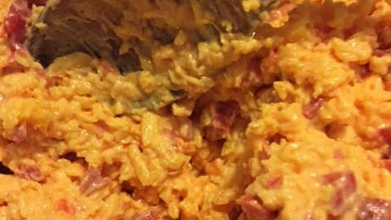

Ingredients:
8 ounces pimentos, drained and finely chopped (I buy 4 of the little 2-ounce jars of the diced pimentos that you can find in every grocery store)
2, 8-ounce blocks of sharp Cheddar cheese, grated (I do it in a food processor)
½ cup mayonnaise
White sandwich bread

Preparation:
Combine the pimentos and cheese, beating until smooth (I use an electric hand mixer). Beat in the mayonnaise. I like mine chunky but, if you don’t, pulse the cheese and pimentos in a food processor until smooth. This spread freezes well.

The traditional way to serve this spread is on slices of white sandwich bread while the mixture is room temperature. I like to put some pickle slices on mine!

This stuff also makes fabulous grilled-cheese sandwiches.

