No-Bake Peanut Butter Oat Bars (recipe makes 6 – 8)

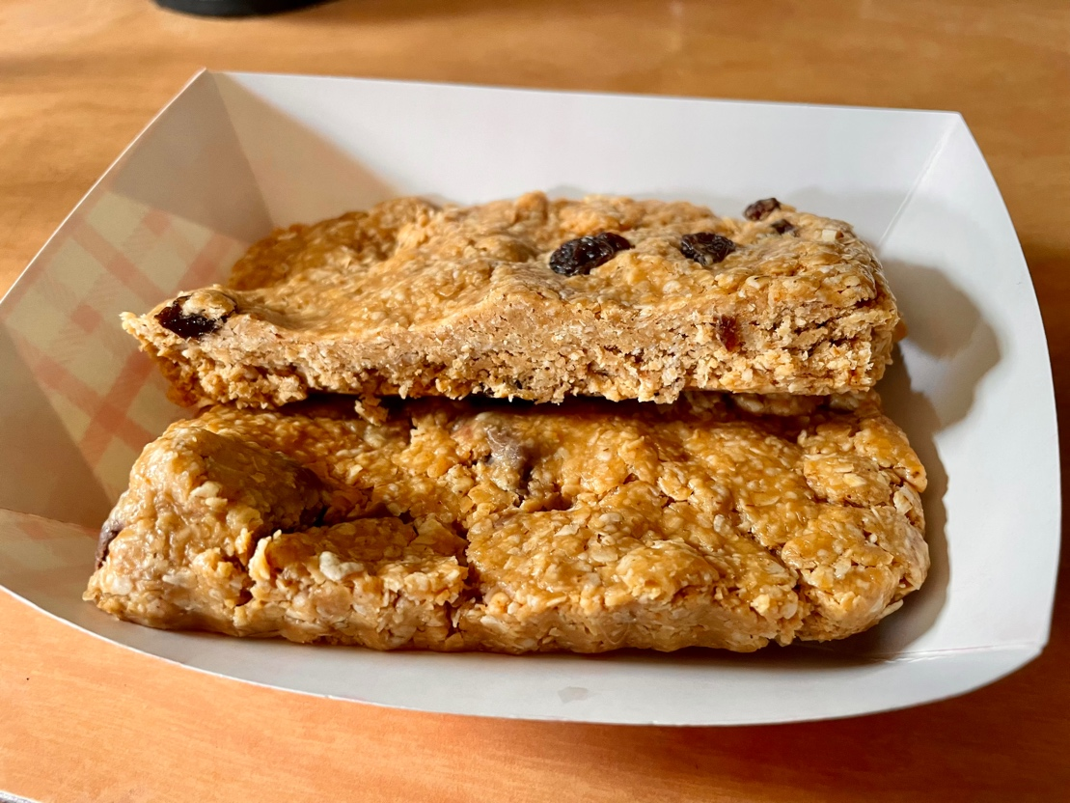

Ingredients:
1 cup creamy peanut butter (I do use Jif, Skippy or another common American brand because they're sweeter and easier to work with)
½ cup honey
2¾ cups quick oats
½ cup raisins, chocolate chips, other dried-fruit bits, nuts or whatever else you want to add in (I like cutting German Ritter Sport chocolate bars into their little square sections)

Preparation:
Lightly spray an 8" x 8" pan with nonstick spray (I use disposable foil pans about 7" x 11" and about an inch deep).

In a large glass mixing bowl, heat the honey a few seconds in the microwave until warm, then mix it well with the peanut butter with a spatula until smooth. Combine with oats and raisins/chocolate. I put on plastic food handlers’ gloves and kneed the "dough" into a ball, which is easiest then to press down into the pan. Sometimes I divide it into two and make one side with raisins and the other with chocolate!

Press into prepared pan - the dough will only be about an inch in height in your pan after pressing it evenly into the edges.

Place in refrigerator until cool and set, about 15 minutes or so. Cut into squares. It can then sit out and be cut/served at room temperature.

