Virtually No-Carb Slider Buns (recipe makes 4 buns)

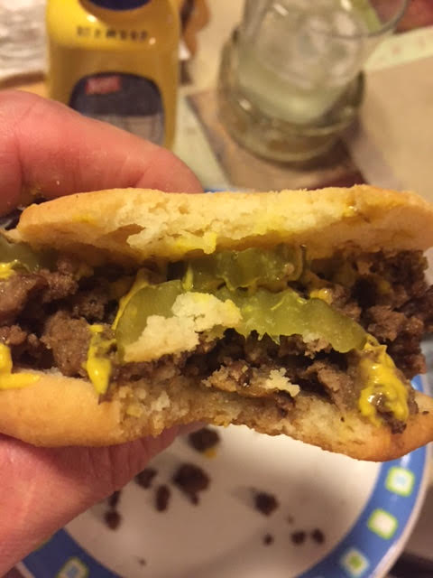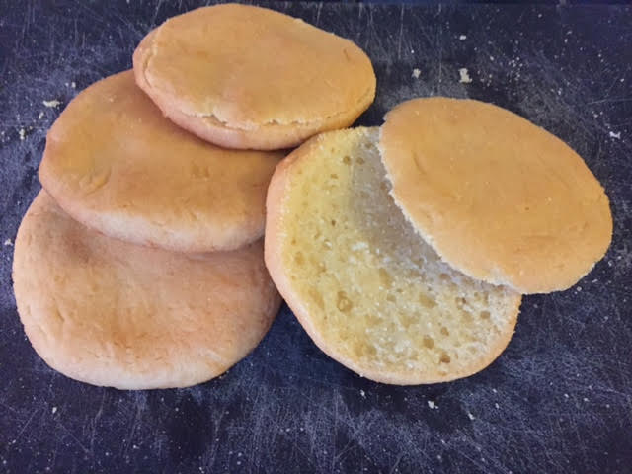

Ingredients
1 cup tapioca flour
½ cup coconut flour
½ teaspoon regular table salt
½ teaspoon baking powder
½ cup warm water
½ cup olive oil
1 large egg, beaten

Instructions
Preheat oven to 350° F.

Combine the tapioca flour with the salt, coconut flour and baking powder in a medium bowl. Mix well with a whisk.

Pour in the oil, warm water and the whisked egg; mix until well combined. If the mixture is too thin, you should add one or two more tablespoons of coconut flour – one tablespoon at a time – until the mixture is a soft, but somewhat sticky dough.

Scooping out ¼ of the dough at a time, roll each quarter into a ball, then flatten each out into the size of a slider bun on a parchment-lined baking sheet. There should be enough oil in the dough so that it doesn’t stick to your hands, but just dust them with a little tapioca flour if the dough sticks.

Bake 35 minutes. Allow to cool, then carefully slice each bun open so that you have a top and a bottom, like a little hamburger bun.

